Transfers GL to GL-
Log onto Cornerstone- https:/my.rutgers.edu
Click on “Financial Management (Oracle Cloud)”: 
Click on “General Accounting”: 
Click on “Journals”: 
Click on the “task icon”: to select which method you want to create your journal entry with (either through the form, or spreadsheet)
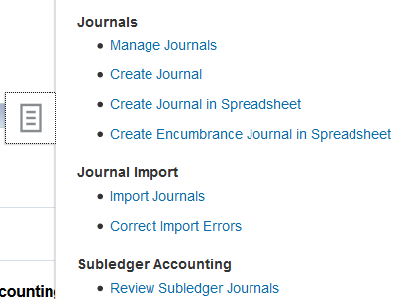
Click “Create Journal in spreadsheet” to use the spreadsheet
Click “Create Journal” to use the form

Using the form (and field with 1 “*” is mandatory, you need to fill out those sections-
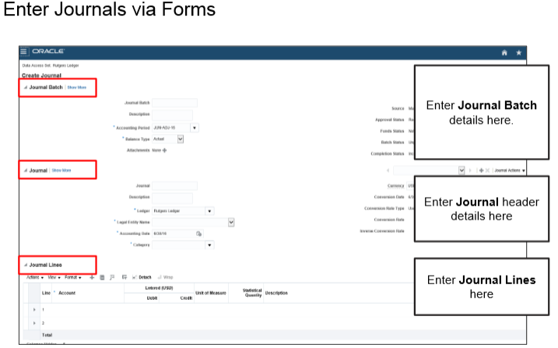
Journal Batch-
- Accounting period- should be the MMM-YY of the fiscal year you are using for adjustment
- Balance Type- keep as “Actual”
Journal-
- Description- should be the detailed entry for what you are transferring:
  - Example- moving $100 to Global to cover visa fees for Professor Smith
- Ledger- keep as Rutgers Ledger
- Legal Entity Name- Rutgers, The State University of New Jersey
- Accounting Date- is the date of your transfer
- Category- RU Actuals

Journal Lines-
- Journal Lines are where you would enter your journal entry-
  - debiting the losing GL string for the dollar amount you need to move and crediting the gaining GL string for the same dollar amount
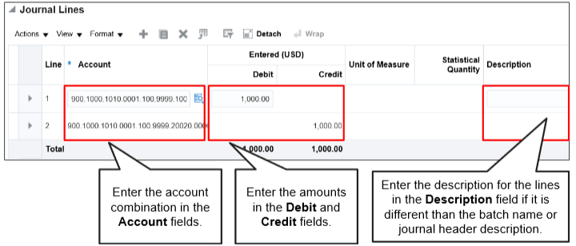
To enter in the GL strings-
Click on the search icon- and type your string- you do not have to search, just click on the number as it comes up:
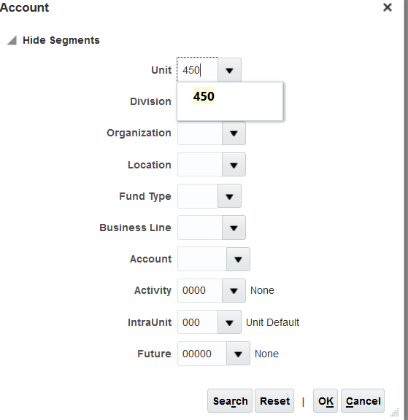
This will show you your string-

When you are done entering your string, click ok
Then you can enter in dollar amount to transfer and your journal entry explanation-
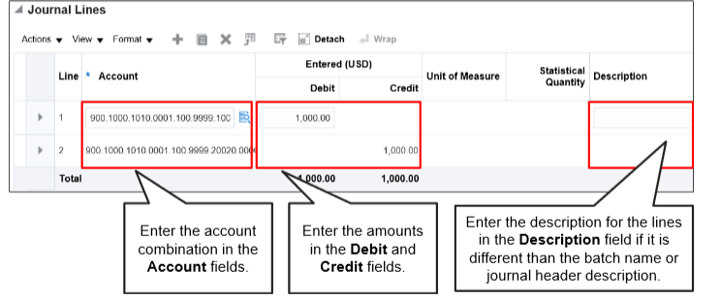
To add an attachment:
Under the “Journal Batch” section, click on the “+”

This will allow you to browse and attach your file-
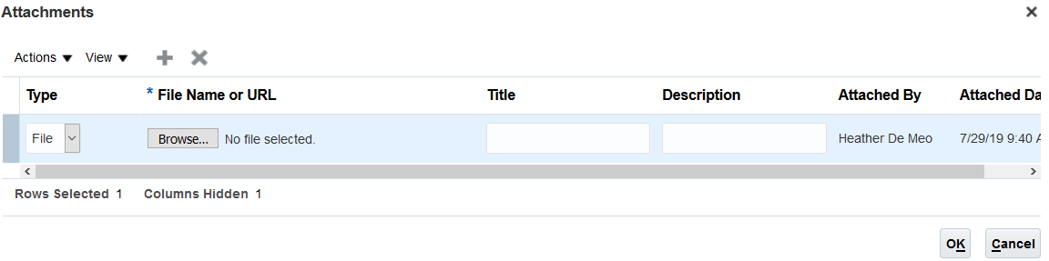
Once you have found your file, click on “OK” to add to the journal entry.

When you are ready to submit-
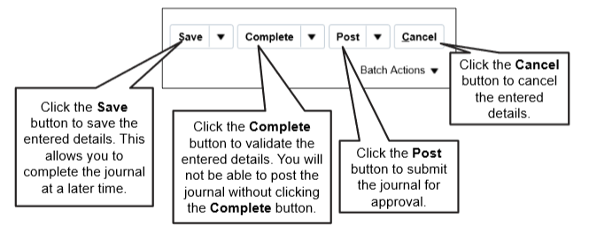
To create the journal in a spreadsheet-
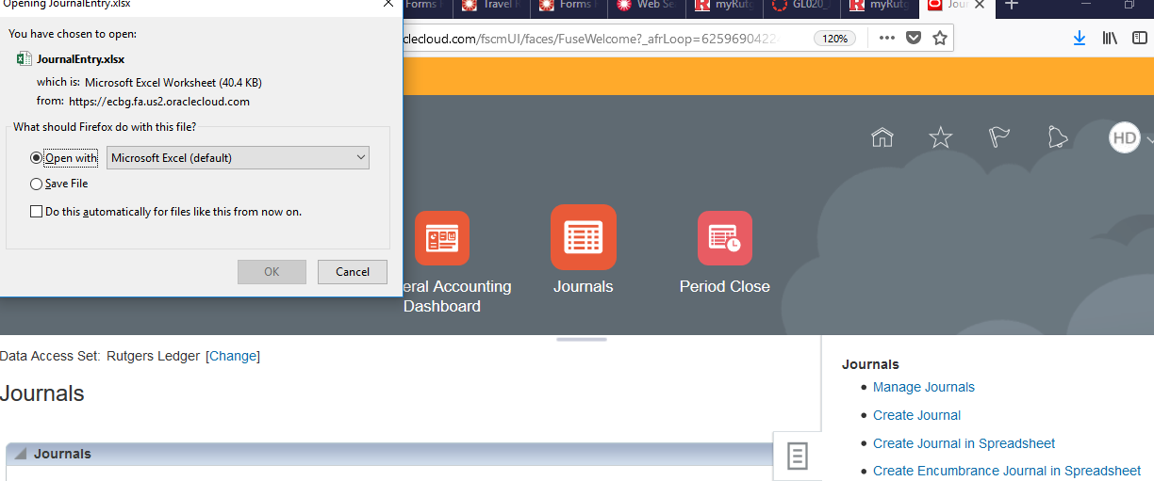
After clicking on “Create Journal in Spreadsheet” click on OK to open up excel
Click on “Yes” and add sign on with your net id and password
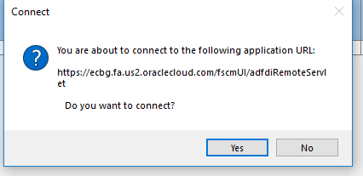
This will open up the spreadsheet-
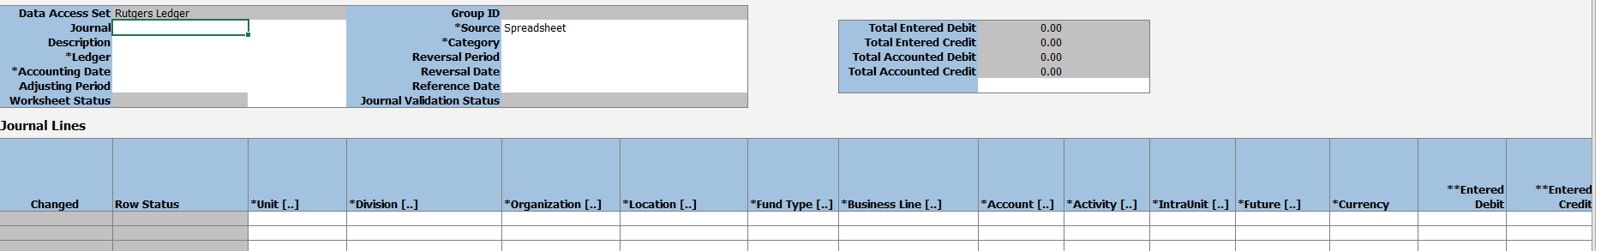
Fill out the spreadsheet- remember anything with 1 “*” is mandatory.
If you are struggling with what to fill in, “double click” the cell with your mouse to open up the search screen-
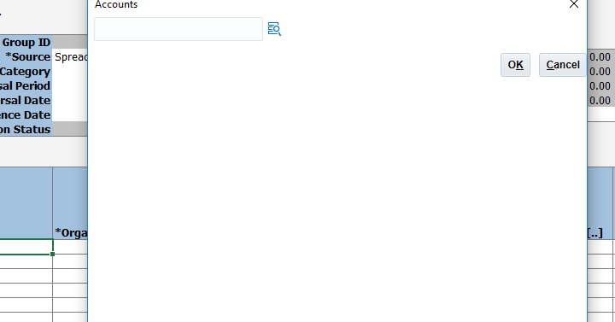
When you are ready to submit-
Click on “Submit” from “Create Journal” and then submit your journal
