Transferring Expenses on a Projects Using Report 073 to find the Expenses-
Expenses can be transferred in the Cornerstone system-
Cornerstone recognizes expenses by the transaction number. You can find the transaction number through “Report 073”
Log onto Cornerstone- https://my.rutgers.edu and click on “Financial Management (Oracle Cloud)”

To run the “Project Report 073”
Click on “Tools” and then “Reports and Analytics”


Project Report 073 is located
Reports and Analytics All Folders Shared Custom RU Custom Reports PGM Reports

Fill in your search criteria-
You can fill in the “Project Number” and the “Accounting Date”. Accounting Date is when the expense hit the ledger.
When you fill out the search criteria, click on “apply” to run your report, it will open in excel-
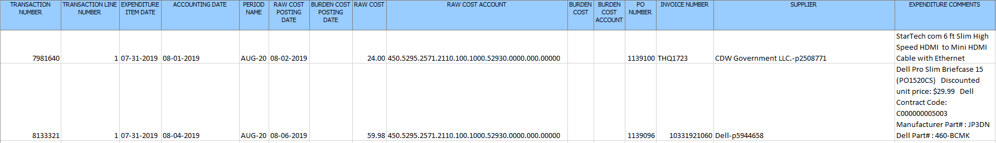
The report will give you all the information on the expenses in the project based on dates listed. Cornerstone will recognize the “Transaction Number” when looking up expenses to transfer.
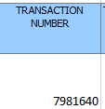
To transfer the expense- go back to “Financial Management (Oracle Cloud): 
Click on “Projects” and then “Costs”

From the task bar on the right side- and click on “Manage Project Costs” from the menu
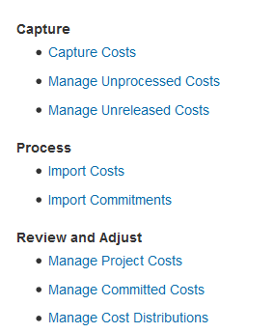

This will open up the basic search screen. Click on “Advanced” to open up the remaining search criteria-

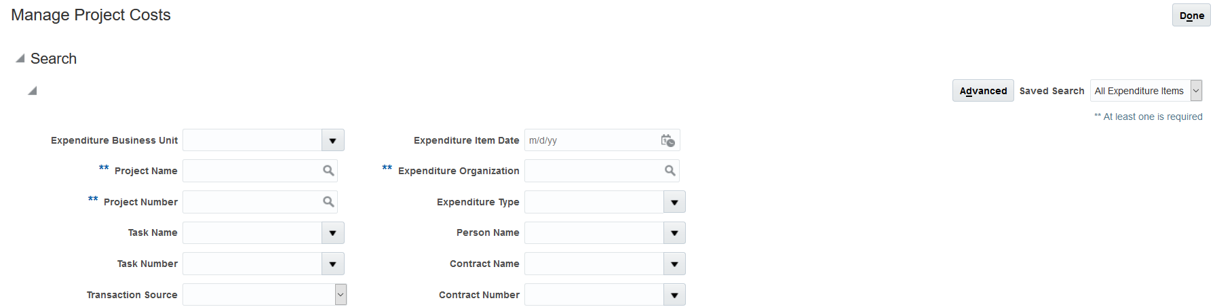
You can fill out the Transaction Number and go straight to your expense-
Enter the transaction number

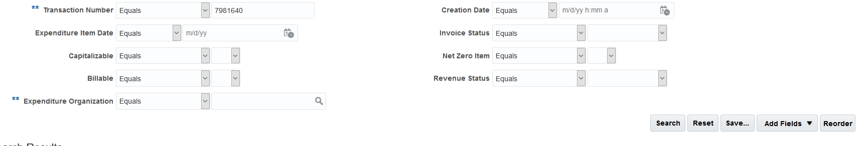
Click on search

This will give you your expense you need to move –
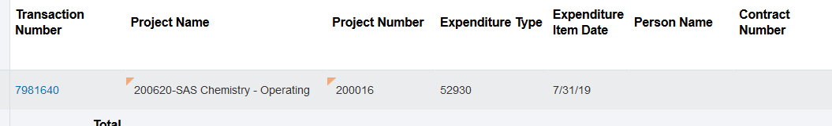
Click on the transaction number

This will bring you into the expense detail, from the “Actions” menu on the right, you can start your transfer-
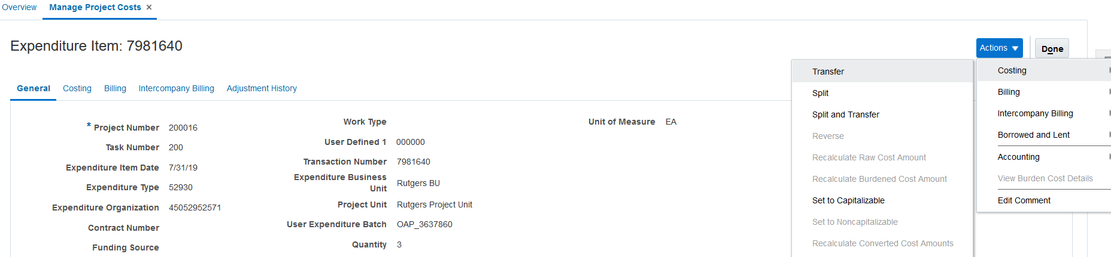
Transfer will allow you to transfer the entire expense to another project. Split and Transfer will allow you to transfer a portion of the expense to another project.

Transfer-
When you click on transfer-
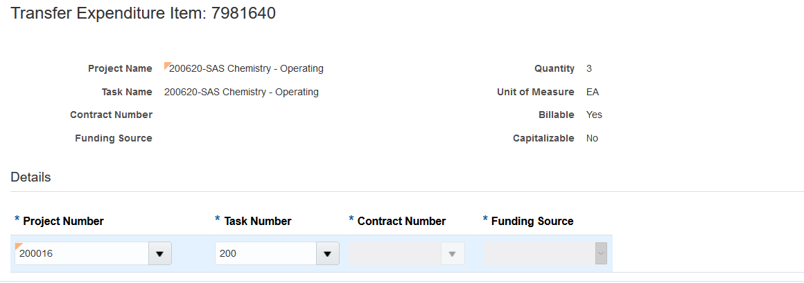
Enter in your project number and task number- if your project is a sponsored project, the contract number will automatically fill in.
When you are done, click on submit in the upper right hand corner
This will open up a “justification box” – fill in your justification and hit “submit” for approval.
Split and Transfer-
When you click on spit and transfer-
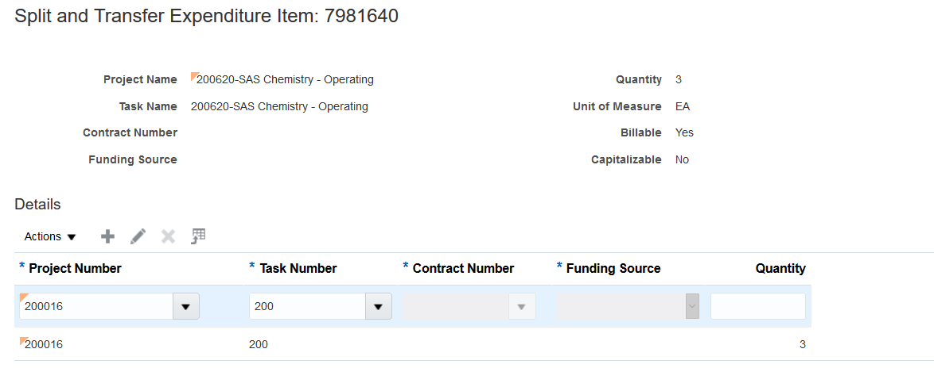
The first line of the project number will be the original project number of the expense. Leave that as is. You can fill in the subsequent project numbers for where you want to move your expense to.
The quantity must total to the quantity in the expense. In the above example, the total quantity is 3, so if we are spitting between 2 projects, the quantity in both line must add to 3 (so the first project can have 1.5 and the second project can have 1.5)
You can add more projects by click on the “+” sign
When you are done, click on submit in the upper right hand corner
This will open up a “justification box” – fill in your justification and hit “submit” for approval.

