Tableau and Payroll
**Please note that these systems will change on 1/1/25 as Rutgers transitions from People Soft to Oracle
Tableau is the system we use to monitor payroll, where people are being paid, and their payroll. This should be monitored monthly or every other month to ensure that people are being paid correctly and to limit employee charging instructions and SWRJ (Salary Wage Redistribution and Justification).
Tableau is found on https://bireporting.rutgers.edu or on https://my.rutgers.edu 
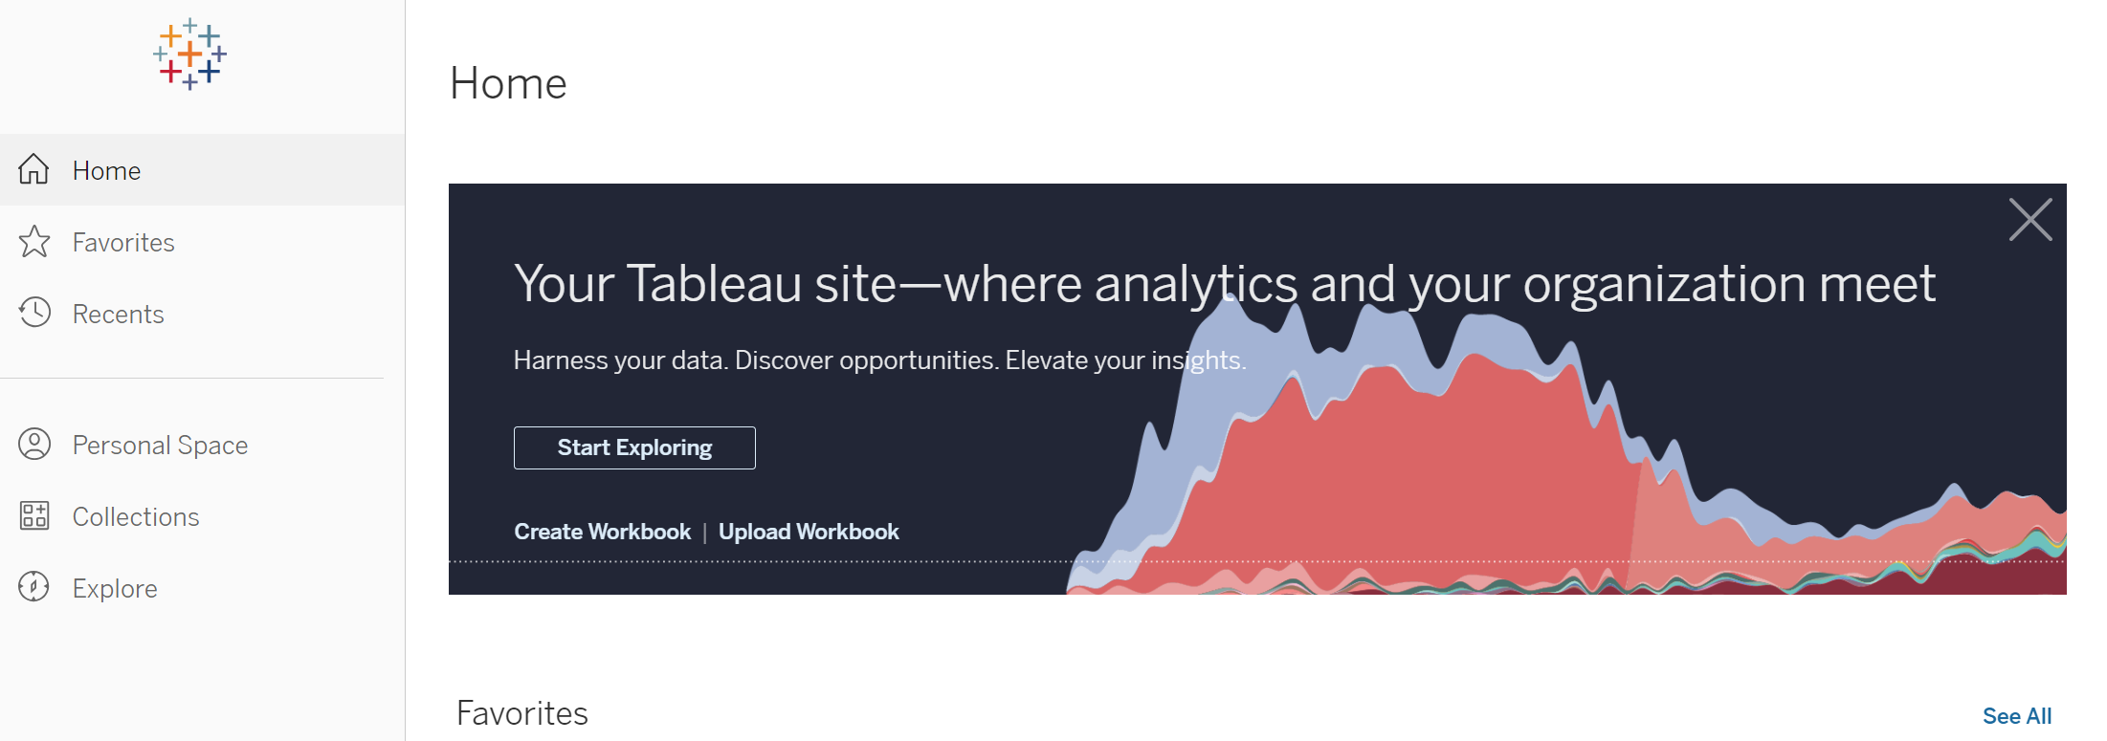
From the home screen, use the following path to get to reports-
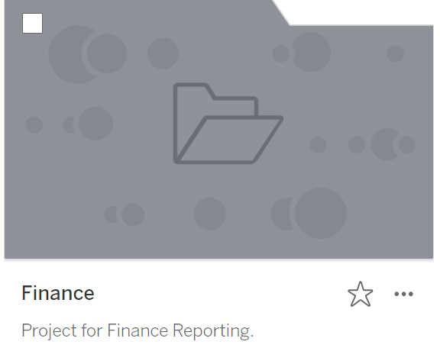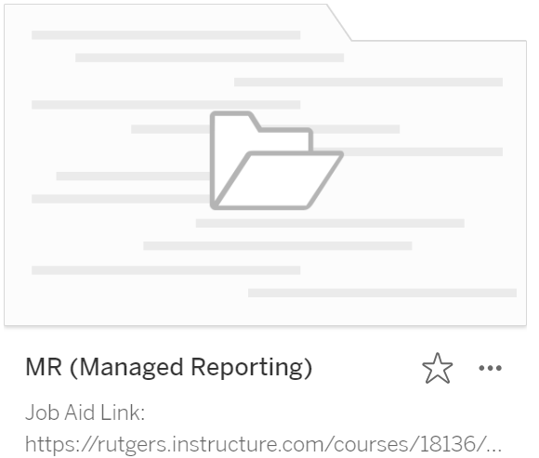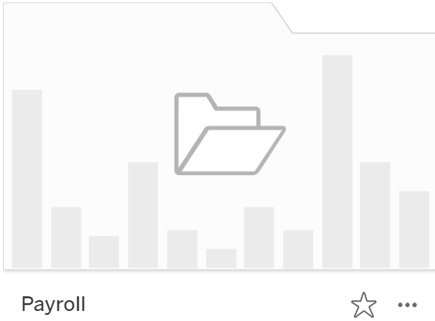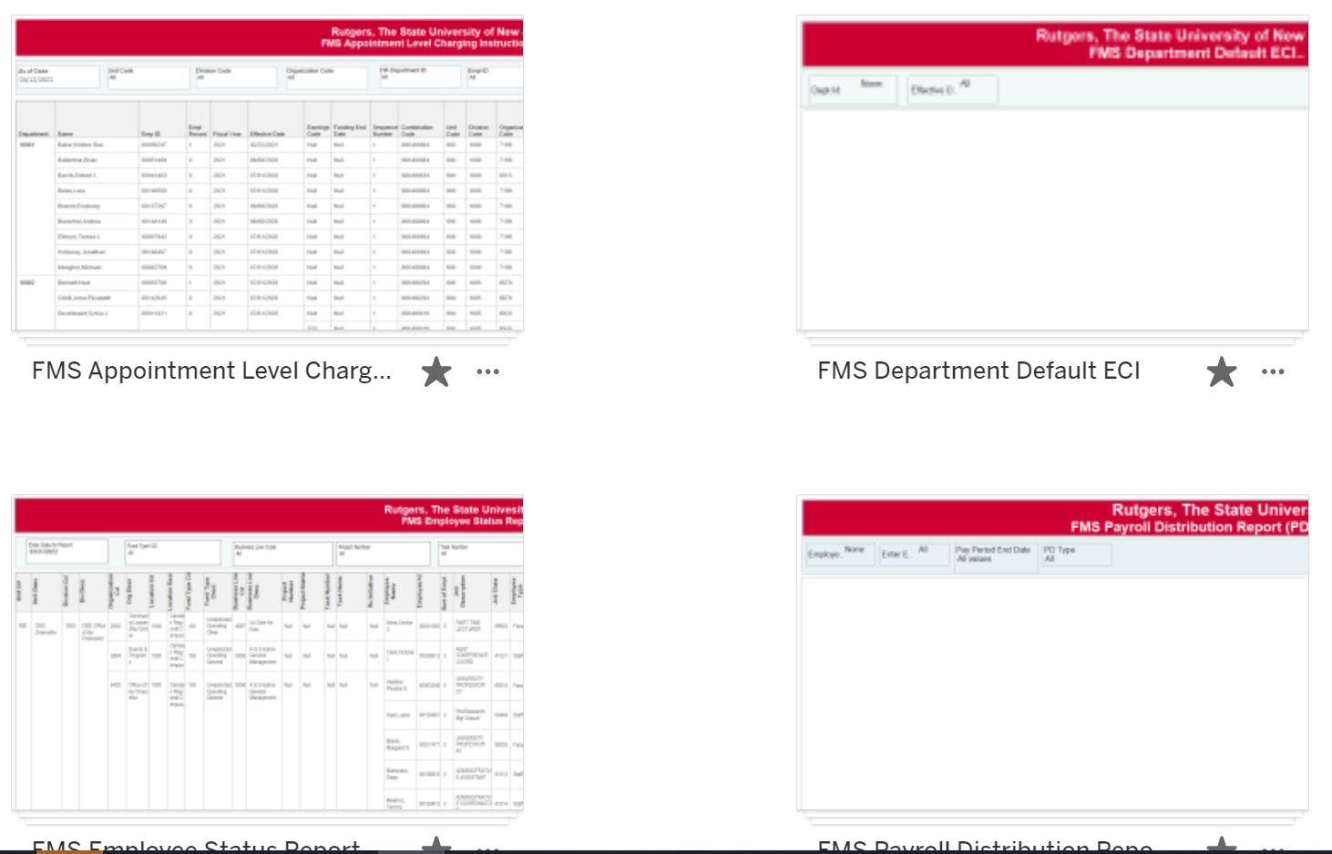

You will have 4 options-
You will get 4 options:
- FMS Employee Status Report
- FMS Payroll Distribution Report
- FMS Appointment Level Charging Instructions
- FMS Department Default ECI
FMS Employee Status Report
The FMS (Financial Management System) Employee Status Report will show you where everyone is being paid on the correct strings.

You have 3 choices-
- By Export List (which wills how you everything)
- By COA (Chart of Account) segment
- By Employee (this will show you all the strings an individual is paid against, even strings not part of SAS)
By Export List;
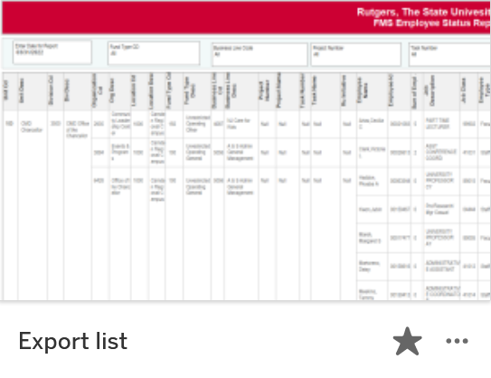
The default will be the current date:
Before you start selecting your search criteria, you need to pause the report- 

If you enter your Unit, Division, and Organization code into the report, you will get everyone paid under your GL (including projects). If you do not wish to see the project, change the “Project” from “All’ to “Null”
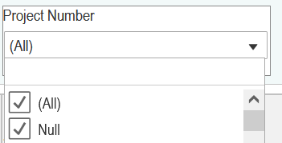
Once you select your criteria, then you need to hit resume to run the report 
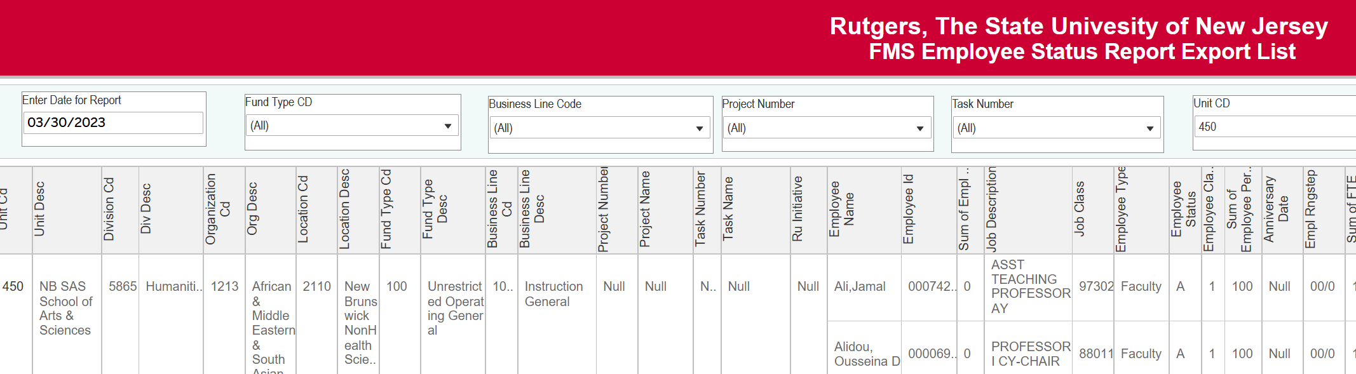
If you need to export, click on the download tab  and select “crosstab” 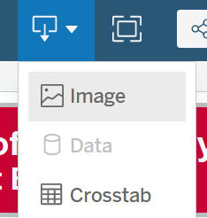
Selecting “Excel” will keep the format of your report, selecting “CSV” will give you the same data unformatted. Be sure to select “Export List”
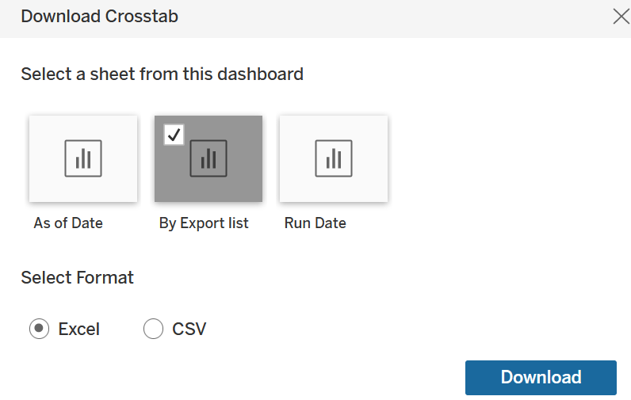

Excel-
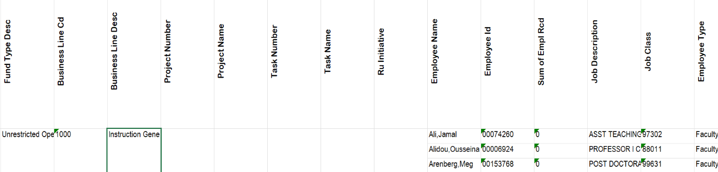
CSV-
If you run it to CSV, be sure when you save it, save it with an excel extension “.xlsx”
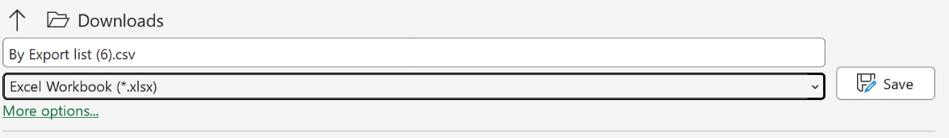
This report will show you the people on each string, how much they are being paid, if they are split, it will show the split percentage that is charged to your string.
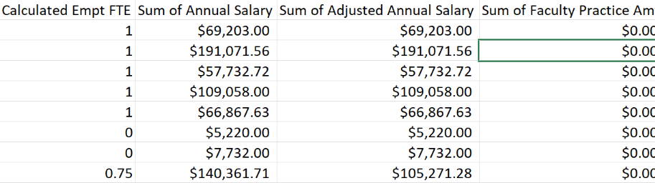

It will also show you the appointment, expiration and tenure dates (expiration and tenure dates are If applicable).
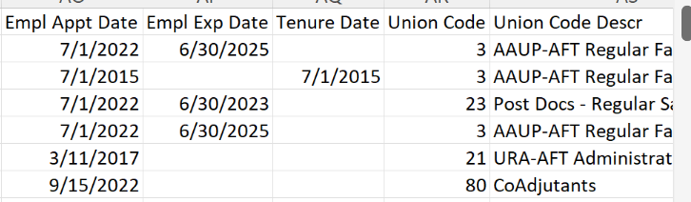
By COA:
This will show you the same information, but break it apart by Chart of Account Segments-
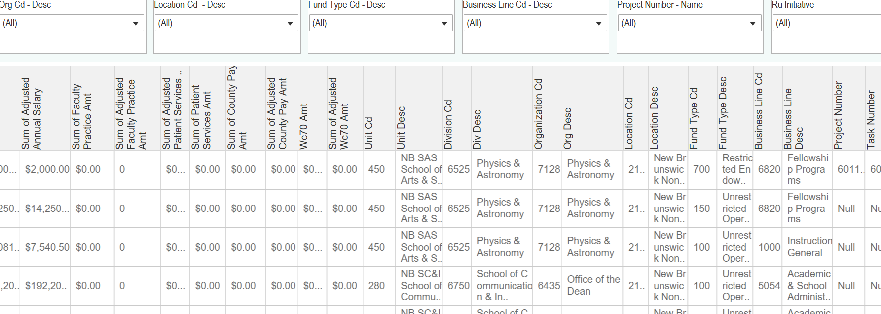
By Employee-
This will show the strings people are paid off.
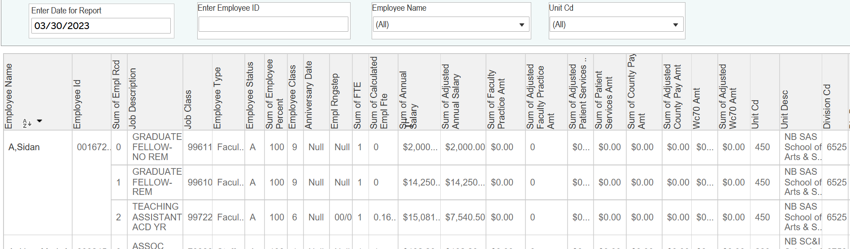
You can search by employee id, or employee name. If you use employee name, it is last name,first name (no space)
This will show you each record, and where the individual is being paid.
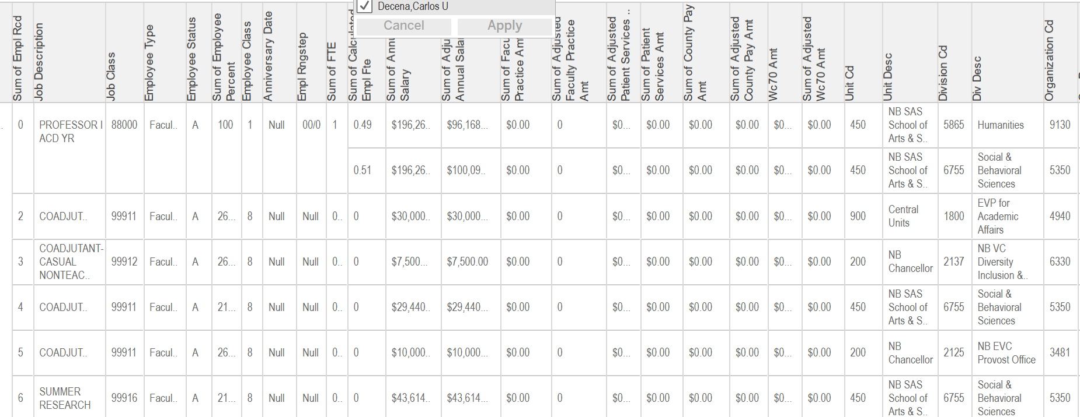
This will show you if they have appointments that are not part of SAS-
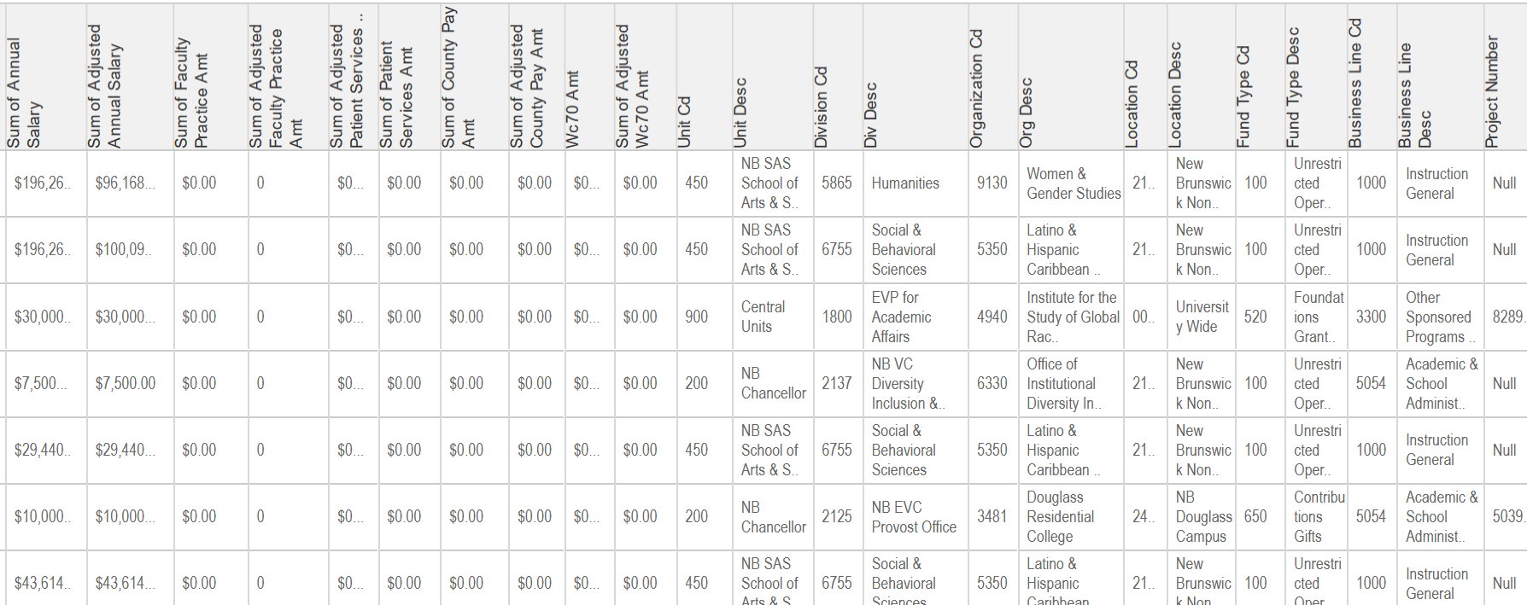
Payroll Distribution-
The payroll distribution report will give you the details about the bi-weekly payroll.
You will get 4 options-
- By COA (Chart of Account) String- FY by GL Posting Date
- By COA (Chart of Account) String- Pay Period
- By EE (Employee) Pay Period End Date Range
- By EE (Employee) and Date Range (Detail)
By COA String – FY GL Posting Date
This report will show you the bi-weekly payroll for the fiscal year you select.
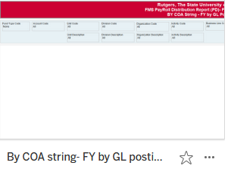
The default is the search criteria-
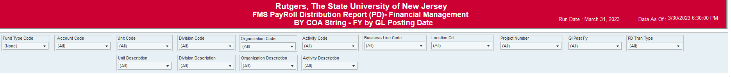
If you enter your Unit, Division, and Organization code into the report, you will get everyone paid under your GL (including projects). If you do not wish to see the project, change the “Project” from “All’ to “Null”
You will need to select the fiscal year you want to search.
To run the report, you will need to select your fund type code. To see everyone, select “All”. 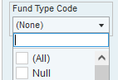
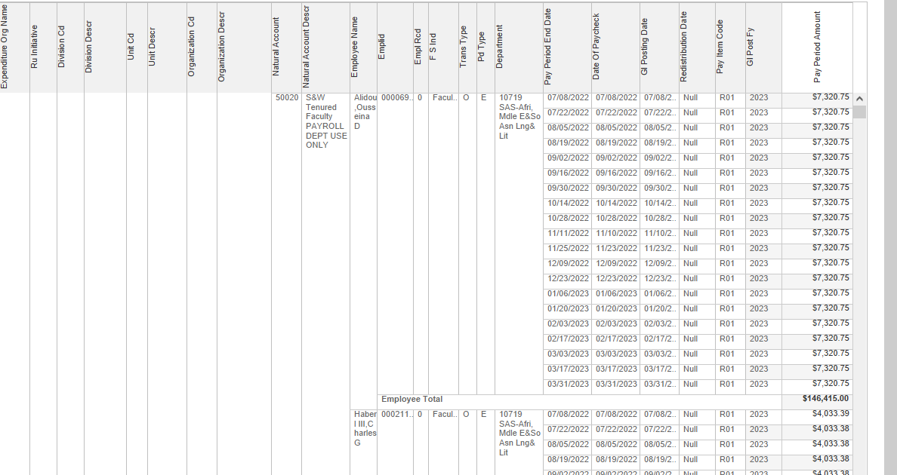
If you need to export, click on the download tab and select “crosstab”
Selecting “Excel” will keep the format of your report, selecting “CSV” will give you the same data unformatted.
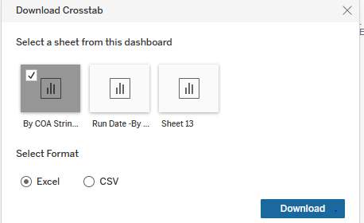
Excel-
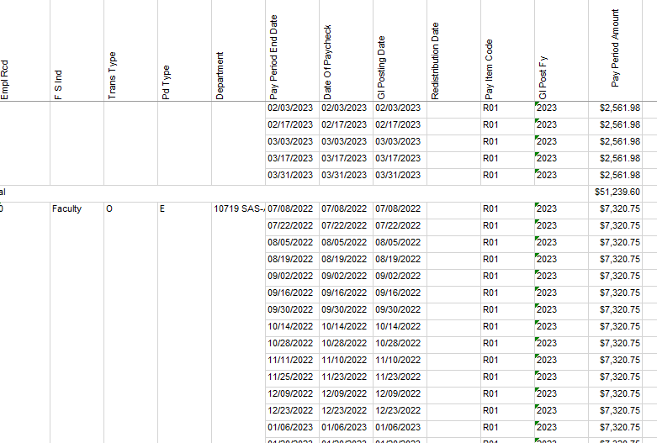
CSV-
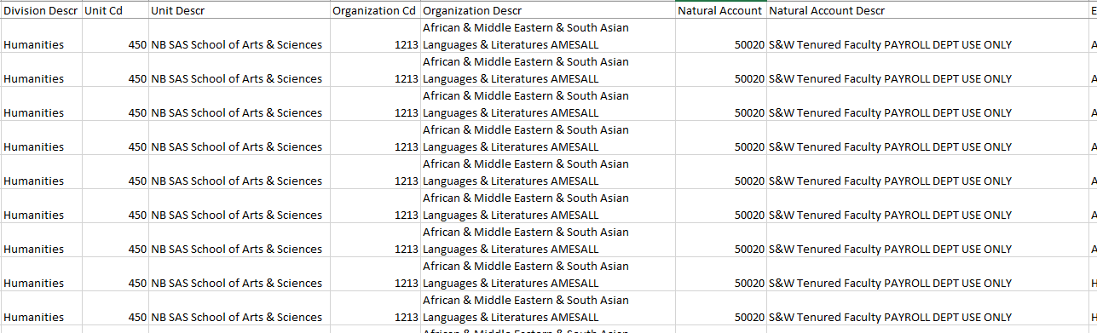
If you run it to CSV, be sure when you save it, save it with an excel extension “.xlsx”
This report is the best way to check to make sure people are being paid as they are supposed to be paid. If you have done Employee Charging Instructions (ECI) or a Salary Reallocation (SWRJ), you can make sure that those were processed correctly.
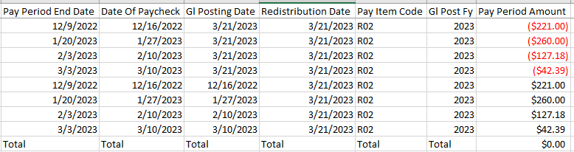
Quick tips:
If you are looking for a certain segment of your organization on the payroll distribution, the report allows you to enter the “Account Code”
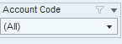
Below is the list of the account codes based on Salary Code, Fringe (if Applicable), FICA and Medicare
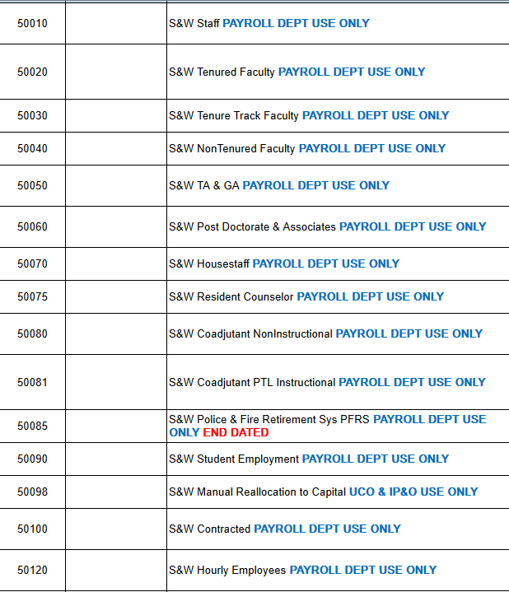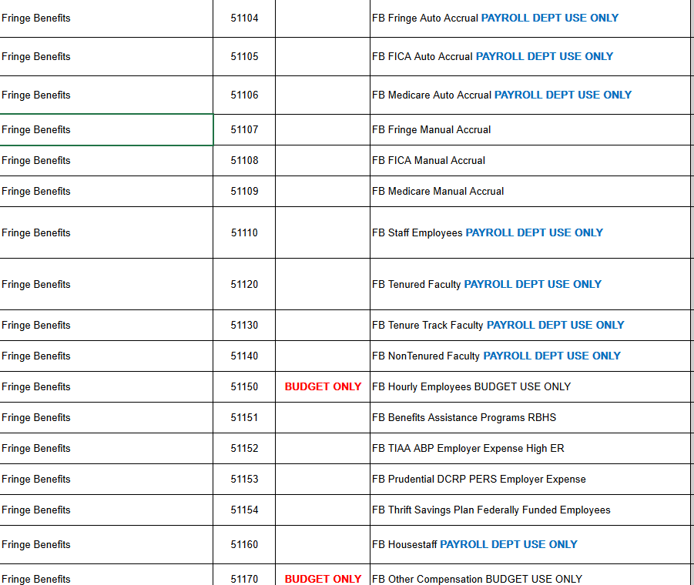
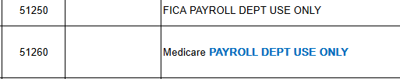
By COA String Pay Period-
This report will show you the same information as the By COA string-Pay Period, but it allows you to select the dates you want to see:
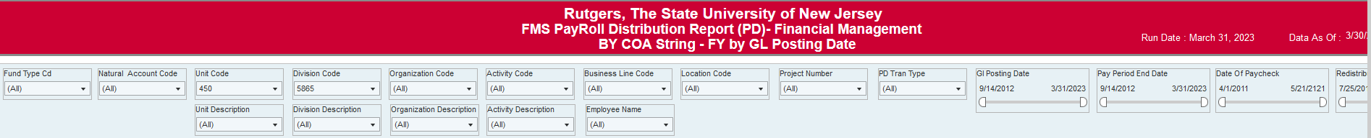
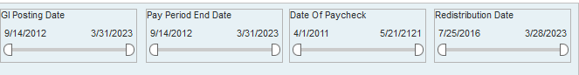
- GL Posting Date: This is when the payroll or redistribution hit the ledger. This date should be set to the date range of the current fiscal period (of when you made the distribution date)
- Pay Period End Date: This is for the pay period in question.
- Date of Paycheck: This is the date of the pay check
- Redistribution Date: This is the date either the ECI (Employee Charging Instructions) or the SWRJ (Salary Reallocation was processed)
Quick tips:
If you are looking for a certain segment of your organization on the payroll distribution, the report allows you to enter the “Account Code”
Below is the list of the account codes based on Salary Code, Fringe (if Applicable), FICA and Medicare
By EE (Employee) & Pay Period Date Range-
This report will allow you to run a payroll report by individual.
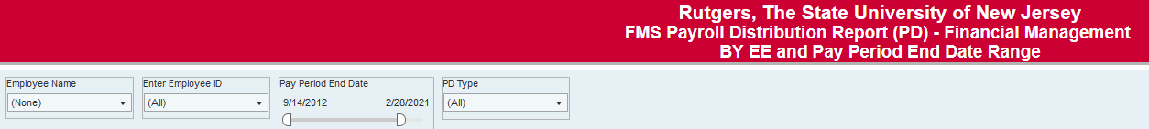
You can search by employee id, or employee name. If you use employee name, it is last name,first name (no space)
Select your date range first, or the report will run based on the default dates.
When you enter in the employee’s name or ID number, the report will run.

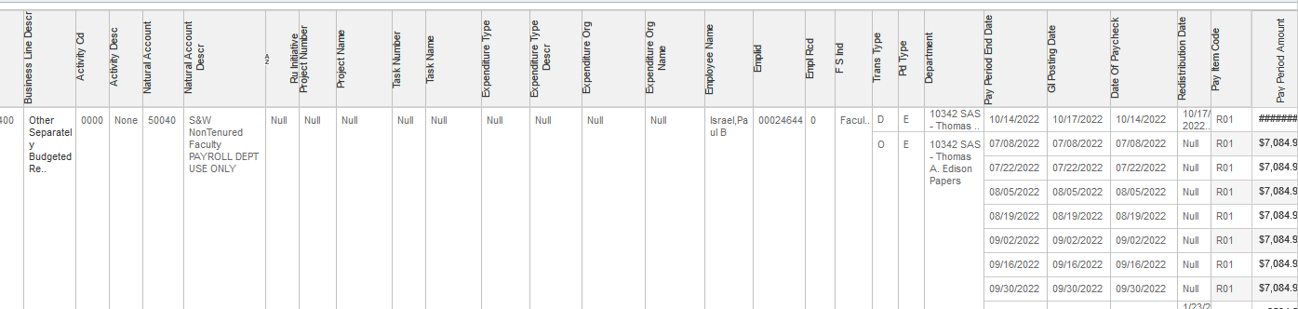
By EE (Employee) & Date Range Detail-
This report will show you the same information as By EE & Pay Period Date Range, but it will allow you select the specific dates to streamline your search to the payroll dates that you want.
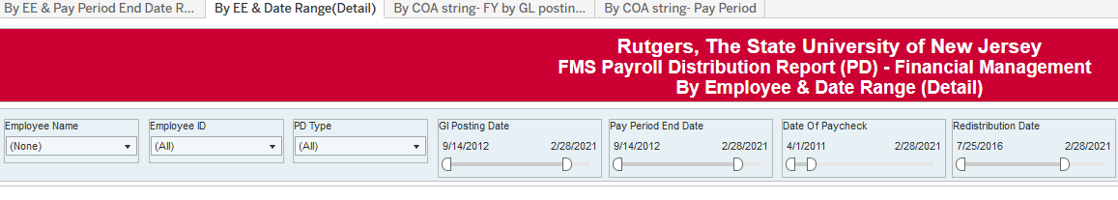
- GL Posting Date: This is when the payroll or redistribution hit the ledger. This date should be set to the date range of the current fiscal period (of when you made the distribution date)
- Pay Period End Date: This is for the pay period in question.
- Date of Paycheck: This is the date of the pay check
- Redistribution Date: This is the date either the ECI (Employee Charging Instructions) or the SWRJ (Salary Reallocation was processed)
FMS Appointment Level Charging Instructions-
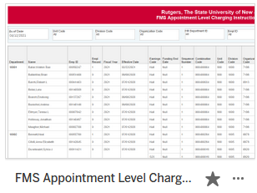
This report will show you the Peoplesoft Combination code by individual based on the UDO, Project Number, or HR Department ID entered.
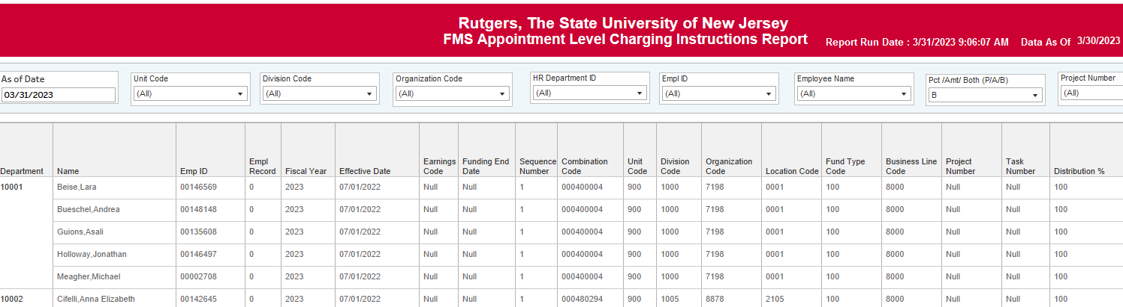
FMS Department Default ECI
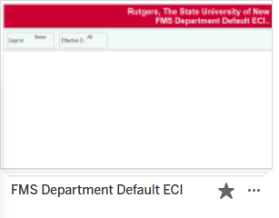
Every department has a default string for payroll. This string is where individuals are initially assigned when they are hired or transferred to a unit.
