Tableau Tuition Reports
Tableau has tuition reports so you can monitor the charges against your GL/Projects.
You need to complete FERPA (Federal Education Rights and Privacy Act) training and GLBA (Security Awareness Training). Once you send in your access form and complete your training, you will have access to the reports.
The report can be found on https://bireporting.rutgers.edu/#/workbooks/5252/views.
This will give you 3 options-
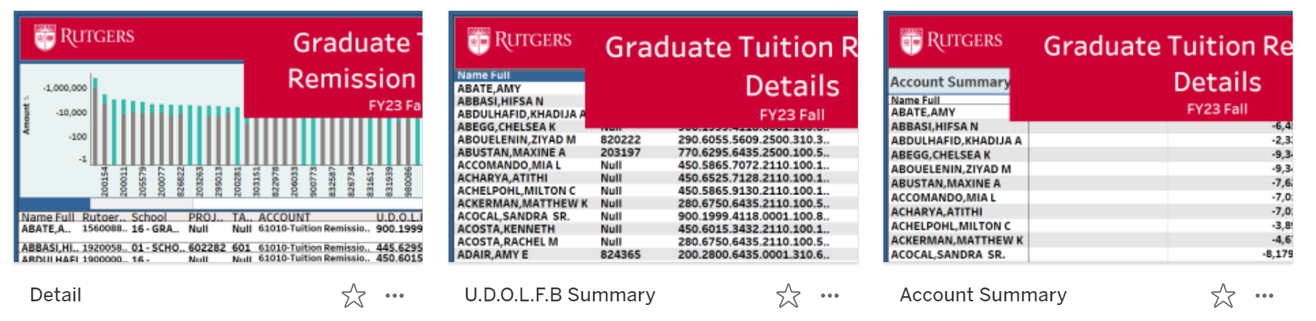
Detail-
When you click on detail, it will open to the main page. Scroll to the right to get to the search criteria.
You will be able to select your search criteria. Be sure to pause the report first before you enter in your criteria. If you do not pause the report, then the report will reset with every item you select. Pausing it will allow you to enter your criteria at once. When you hit resume, your report will run. 
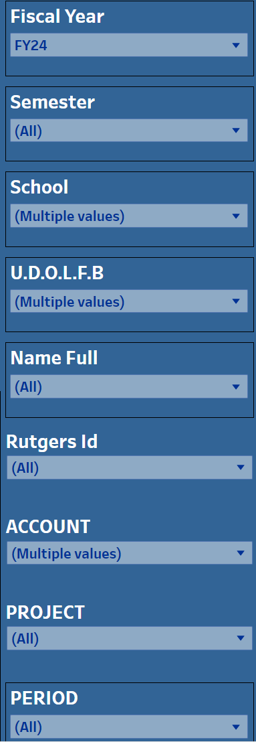
Specific Student Account Codes, select if needed.
Select a specific project, or “All” to bring in all of your projects, “Null” to bring in no projects.
your name.
You can select the account code if you are searching for something specific.
your name.
If you are looking for a specific student, select the ID
your name.
If you are looking for a specific student, select the name
your name.
Enter the string that you want to see
Pick your school, SAS is 01
Pick your Semester
Pick your Fiscal Year

Your report-
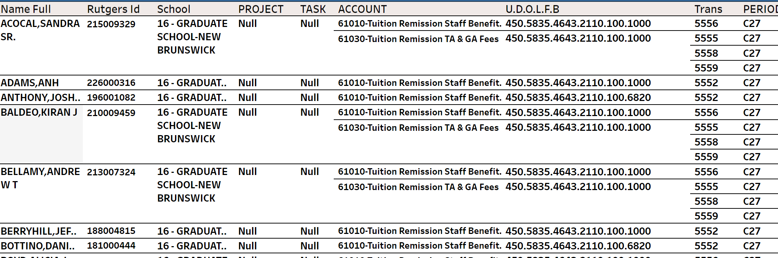
You can export it to excel- 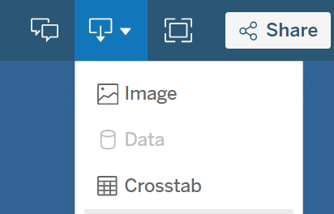click on the export icon and then “CrossTab”
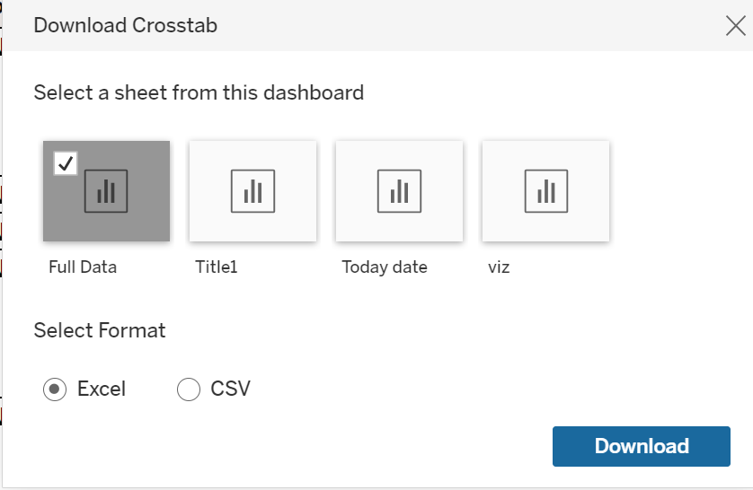
This will give you your report to review-
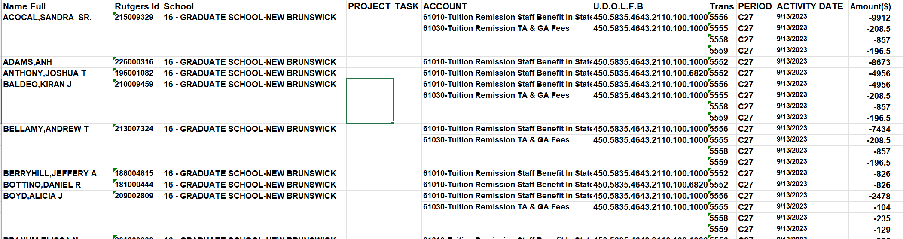

U.D.O.L.F.B Summary (Unit.Division.Organization.Location.Fund Type.Business Line)
Scroll to the right to see the search criteria.
Select your data-
criteria at once. When you hit resume, your report will run.
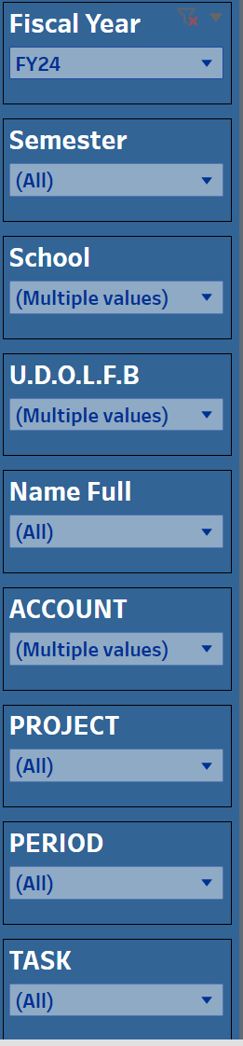
Pick your Semester
Pick your school, SAS is 01
Enter the string that you want to see
If you are looking for a specific student, select the name
your name.
Specific Student Account Codes, select if needed.
Select the task number if you need a specific task
your name.
You can select the account code if you are searching for something specific.
your name.
Select a specific project, or “All” to bring in all your projects, “Null” to bring in no projects.
your name.
Pick your Fiscal Year
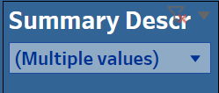
Select the description of the type of charges you are looking for.
your name.

You can export it to excel- click on the export icon and then “CrossTab”
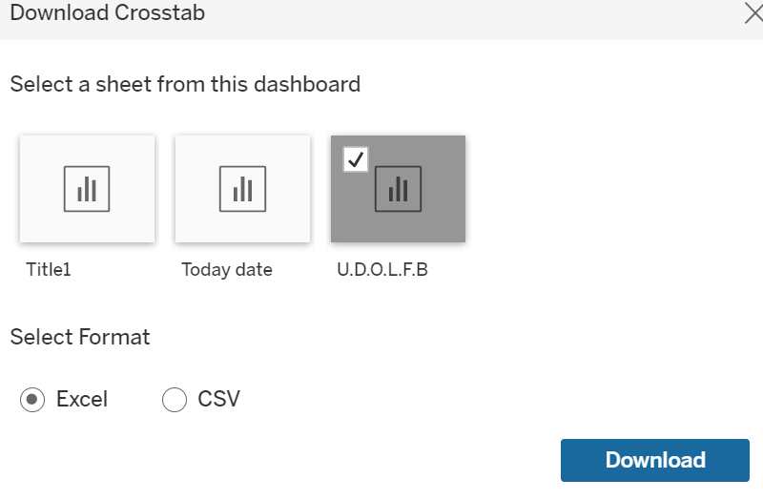
This will give you your report to review-
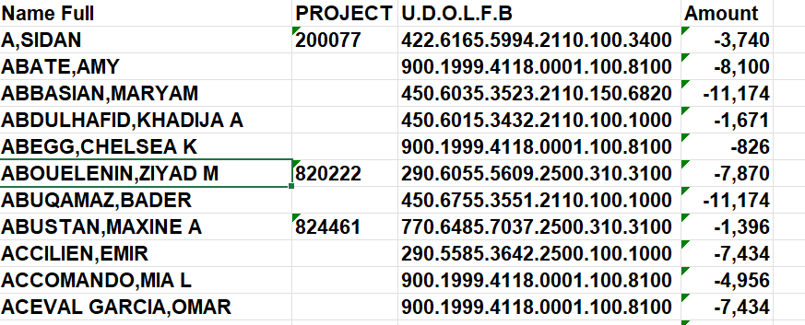
Account Summary-
Scroll to the right to see the search criteria.
Select your data-
criteria at once. When you hit resume, your report will run.
Select the description of the type of charges you are looking for.
your name.
Pick your Semester
Pick your school, SAS is 01
Enter the string that you want to see
If you are looking for a specific student, select the name
your name.
Specific Student Account Codes, select if needed.
Select the task number if you need a specific task
your name.
You can select the account code if you are searching for something specific.
your name.
Select a specific project, or “All” to bring in all your projects, “Null” to bring in no projects.
your name.
Pick your Fiscal Year
You can export it to excel- click on the export icon and then “CrossTab”
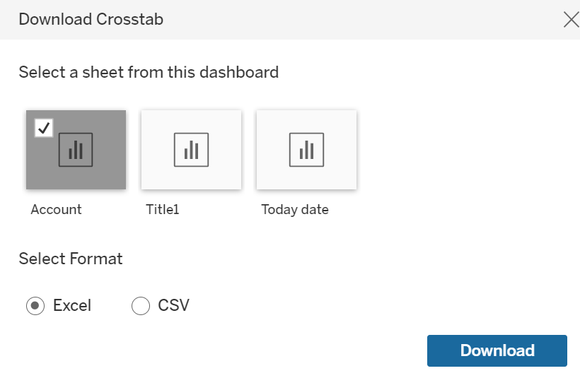
This will give you the report to review-
