Tableau/OAC Form Instructions

Before You Begin
- Set up a DocuSign account using your Rutgers email if you don't have one. Visit: https://it.rutgers.edu/docusign/getting-started-with-docusign/
- Gather names and email addresses of all required signers:
  - Applicant
  - Business Manager (Your DDA)
  - Tableau Content Manager (Ann Lu-Wong)
  - Dean, Director, or Department Chair (Laura Danson)
Filling Out the Form
- Access the Tableau/OAC Form link here --> Click Here <--
- Enter information for all required signers, including yourself as the form preparer).
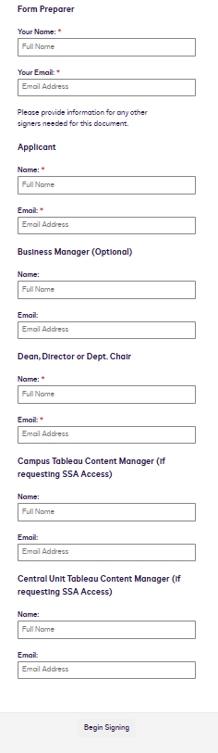
- Click "Begin Signing" to start the form.
- Fill in all required fields.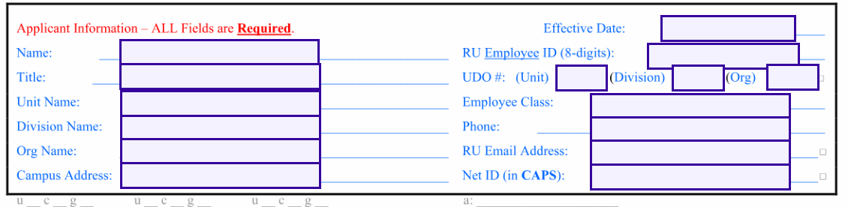
- Select the data requirements and type of access needed. Note: If you select SSA access please select the campus and/or central unit data access.
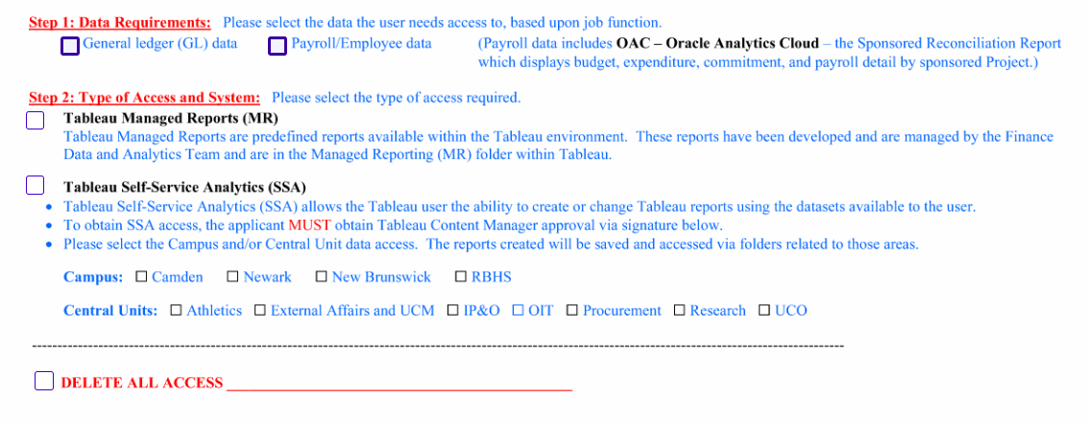
- When finished, click "FINISH" at the top or bottom of the window.
After Completing the Form
- Save a copy of the form for your records.
- The form will automatically route to the next signer.
- Each signer will receive an email to review and sign the document.
- Once all signatures are obtained, all parties will receive a copy of the completed form.
Final Step
The form preparer must save the completed form with the applicant's name (e.g., "John Doe - Tableau/OAC Access Form") and email it to cloudaccess@finance.rutgers.edu for processing.
Important Notes
- Use your Rutgers email for all communications.
- Check spam folders if you don't receive expected emails.
- You can save and finish the form later by clicking "OTHER ACTIONS" or "FINISH LATER".
- Processing may take up to 10 business days.
- For questions, contact cloudaccess@finance.rutgers.edu.

