505 Report-
The 505 report is a report that allows you to see 9 aspects of project reports.
https://my.rutgers.edu
Log onto 
Go to: “Tools” and then “Reports and Analytics”

Follow the following path:
All Folders Shared Custom RU Saved Queries Projects 505 – Project Cost, Revenue Budget, Commitments

This will open up 9 report queries-
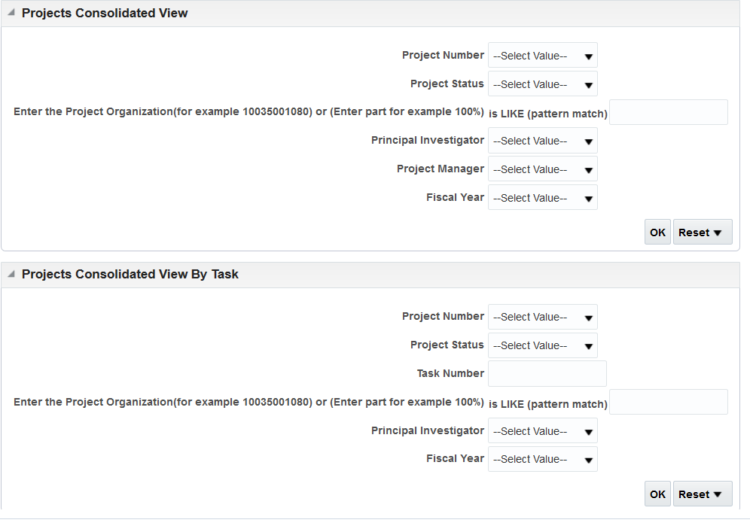
Project Organization is the UDO (Unit, Division, and Organization as 1 number)
You can enter your search criteria by either typing it in, or searching for the value

Project Consolidated View-
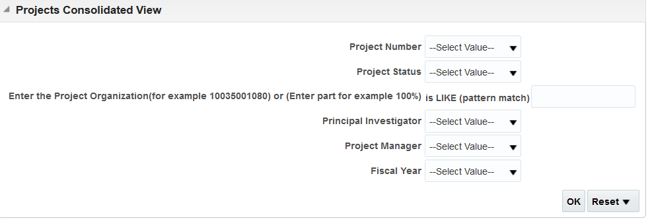
This report will show you project status, PI (if applicable), Project Manager, Budget (if applicable), Cost, F&A Cost (if applicable) Total Actual Costs), Commitments, Available Balance Without Commitments, Available Balance With Commitments, Revenue Amount, Invoiced Amount, Actual Balance Without Commitments, Actual Balance With Commitments.
If you run the report without a fiscal year, the Actual Balance without Commitments and Actual Balance with Commitments will show you what the balance in your project is.
If you run the report by project organization (UDO), it will show you all of the reports within that organization
If you run the report by project number, it will show you the information per project.
Project Consolidated View by Task-
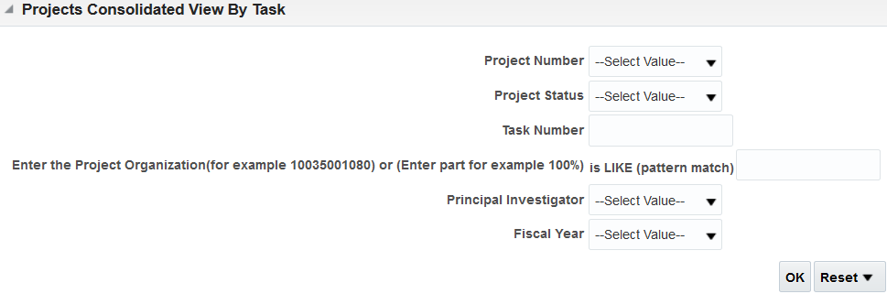
This will show you the same as the Project Consolidated View, but will break apart the project by task.

Projects Consolidated View with Task & Expenditure-
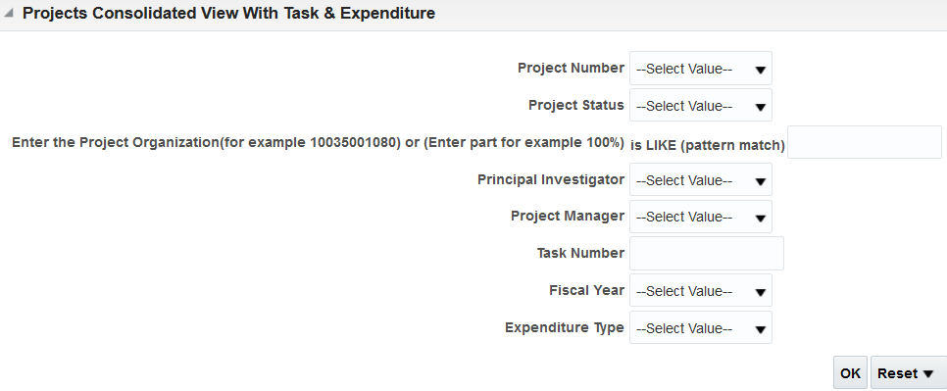
This will break apart the report by expenditure type and task. Please note, that these are total reports, so it will show you the totals for either project to date or conversion to date.
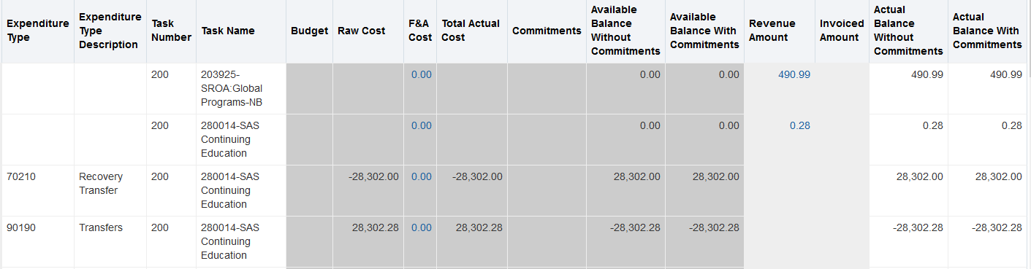
Project Detail with Expenditure Type-
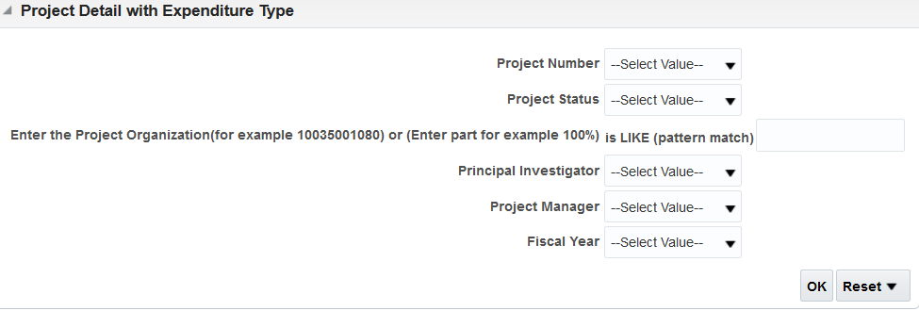
This is a report that will show you items by the expenditure item date. Expenditure Item date is not the date where it hits the ledger, it is the date of purchase. This report will show you the transaction date, which is recognized in Cornerstone.
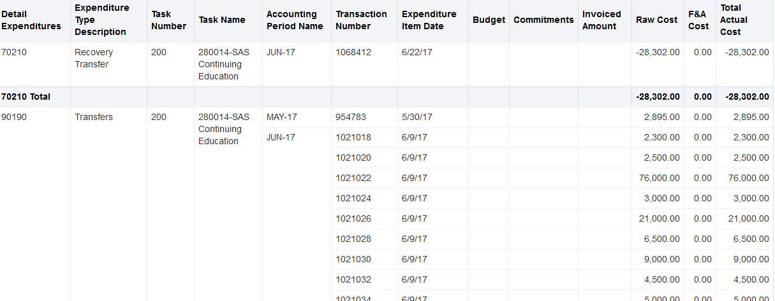
Project Cost & Revenue Report-
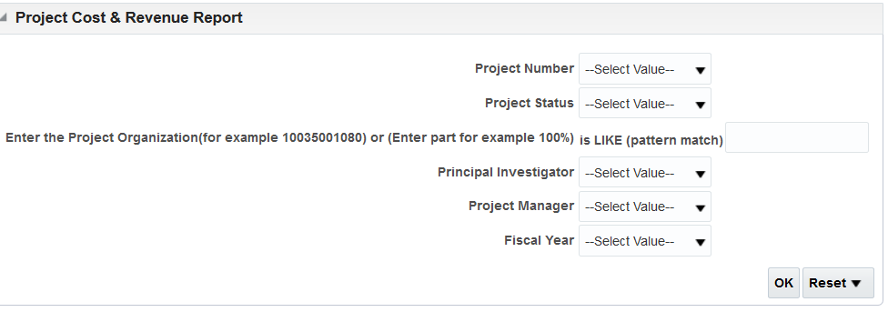
This report will show you the same information as the project detail with expenditure type, however, it will add in revenue if applicable. Please not, the revenue will show with no expenditure type, transaction number, or expenditure type description.
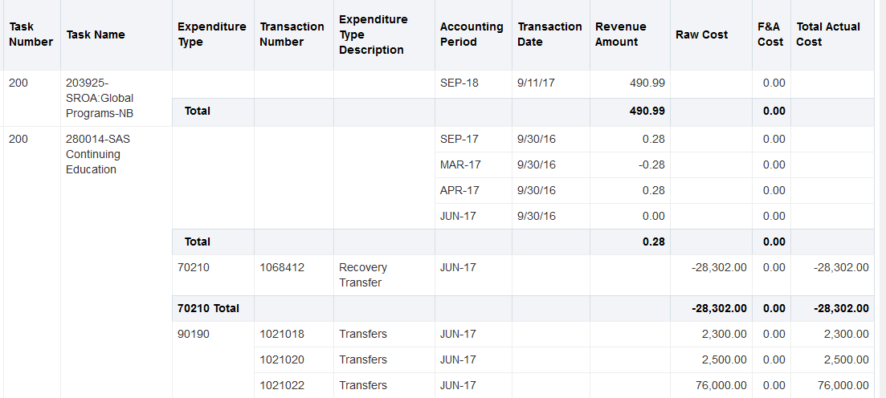
Project Revenue Section-
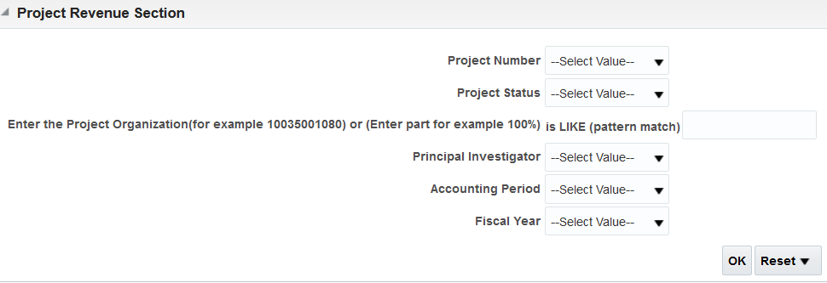
This report will show you what revenue that hits your project-
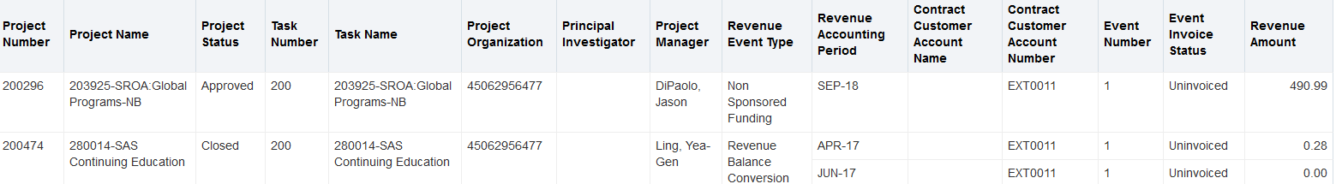

Project Budget Section-
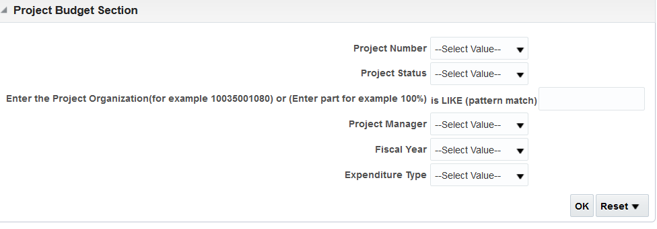
This will show the sponsored budget (grants) for the projects
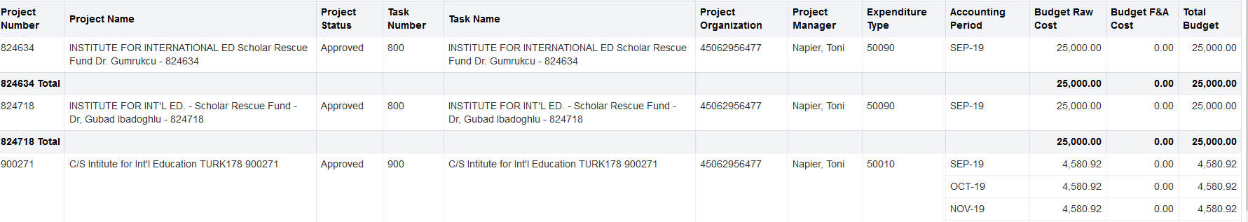
Project Commitment Section-
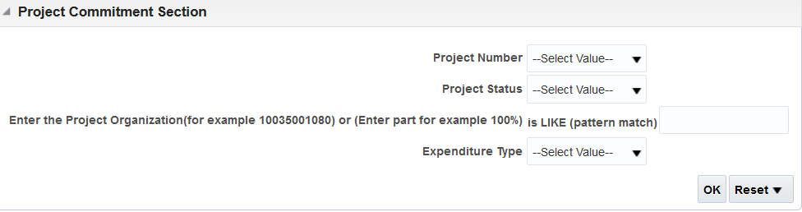
This report will show you the outstanding commitments against your project.
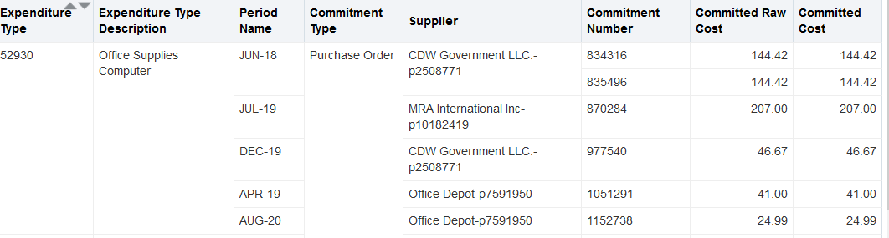
Award Funding-
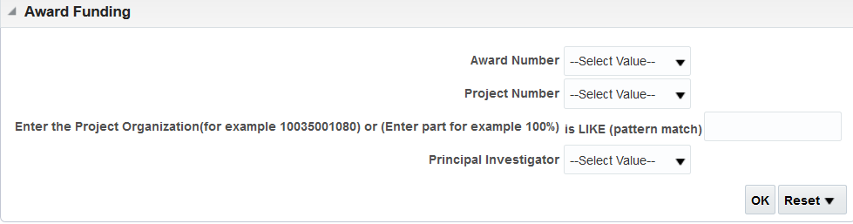
This will give you the details regarding the grant.
