The General Ledger (Report 023)
Report 023 (RU GL 023 Management P&L with MTD YTD & Full Year)-
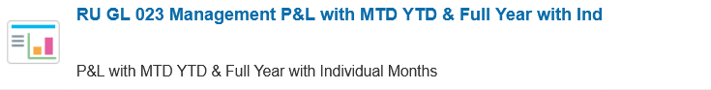
You must enable pop up.
You will get a screen called “Point of Preview” to enter you data-
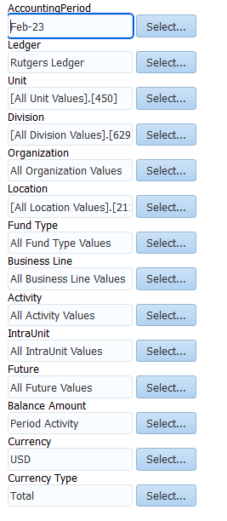
- Accounting Period- Select the fiscal month and year for the period you are searching for
- Ledger- Select Rutgers Ledger
- Unit- (3 digits) Select the School code you searching (SAS is 450)
- Division- (4 digits) Select the division code you are searching
- Organization- (4 digits) Select the organization code you are searching
- Location- (4 digits) Select the location code you are searching (all SAS uses code 2110)
- Fund Type- (3 digits) Select the fund type code for the source of the funds (example, unrestricted operating is 100)
- Business Line- (4 digits) Select the business type code for the mission (example, if you want to see your GL and you teach, you would use 1000- Instruction)
- Activity- (4 digits) Select All Activity Values
- IntraUnit- (3 digits) Select All IntraUnit Values
- Future- (5 digits) Select All Future Values
- Balance Amount- Select “Period Activity” if you want to see activity by month; Select “Ending Balance” if you want the system to total expenses by month
- Currency- Select USD
- Currency Type- Select Total
**Please note, after you select your search criteria, your selections will remain until you decide to change them.
Select “OK” this will lead to another pop up (and it will ask you for the start of your fiscal year). The start of the fiscal year is “JUL-XX” (*XX is your fiscal year.)
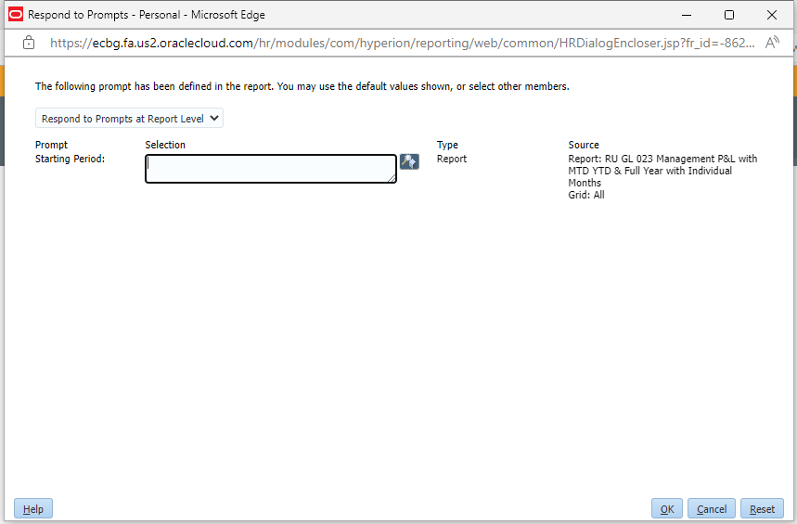
Select “OK”- this will run the report. Your report will open in GGP (Great Grand Parent) level. This report shows both revenue and expenses.
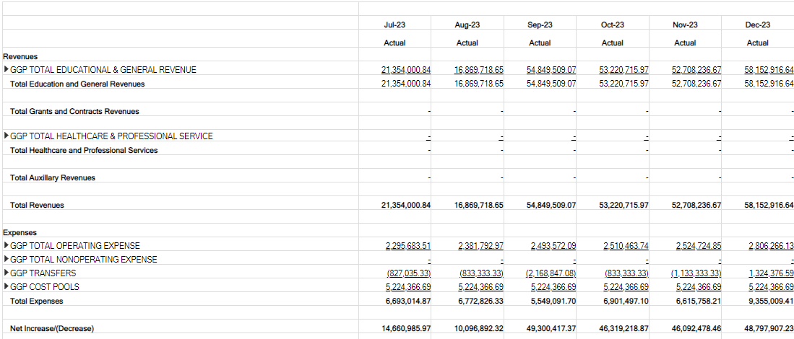
To see more detail, click on the triangle next to the level-
GP is Grand Parent-
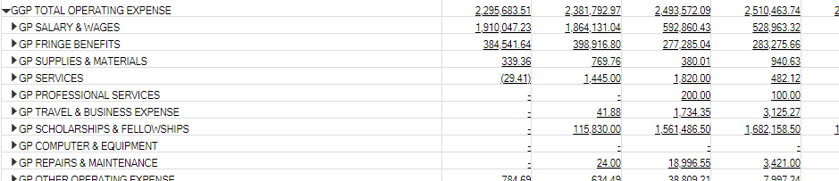
P is Parent-
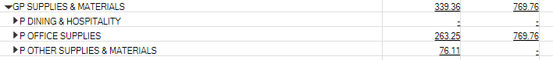
If there is no letter, that is the operational level-
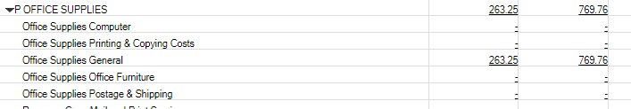
Operational level rolls up to parent level (which is why you see the same number twice).
If you see a number you don’t recognize, you can verify the expense by clicking on the dollar amount- and selecting “Drill to Details Balances” when it pops up- 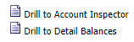
This will open up a new search screen-
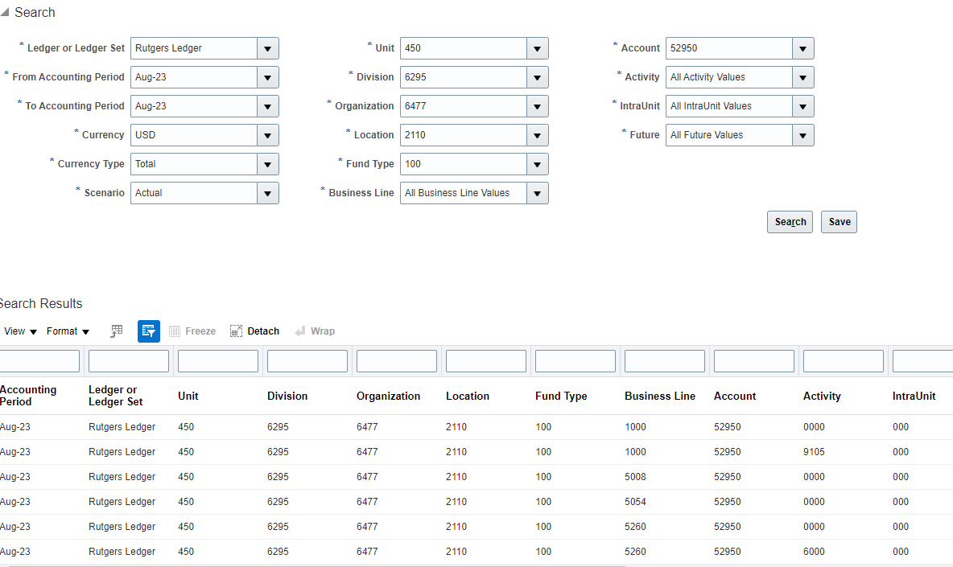
Scroll to the right until you see numbers-
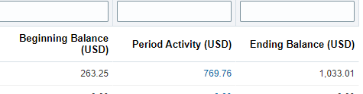
Click on the number in “Period Activity”, this will bring you into the detail-
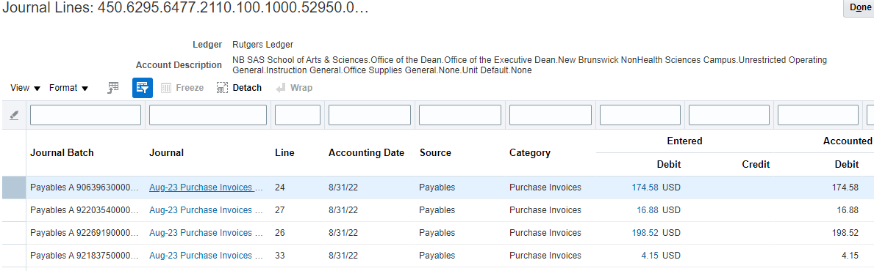
Click on the dollar amount to see the expense-

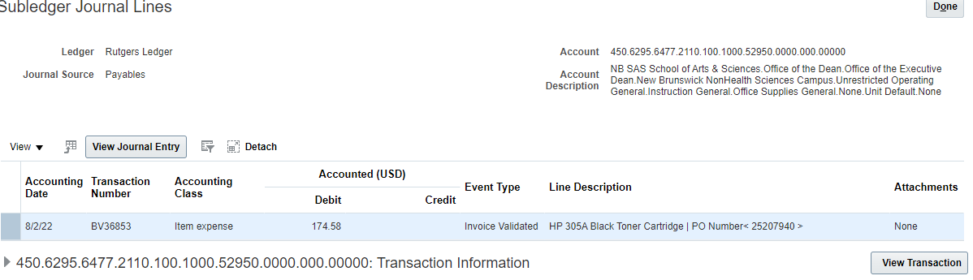

Click on View Transaction to see details and payments-
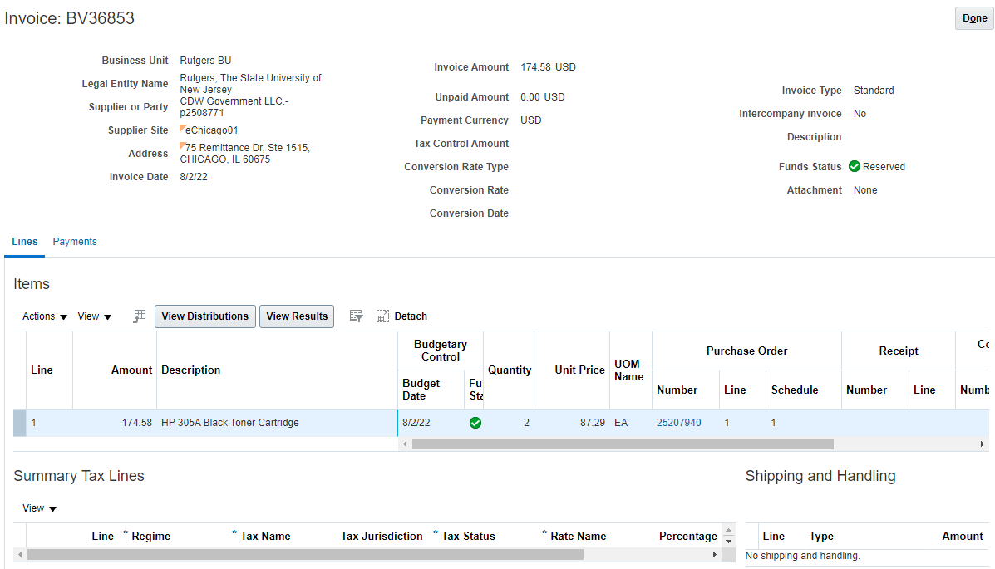
Running Report 023 with “Ending Balance”-
When you run report 023 with “Ending Balance”, the report will have a running total for each month-
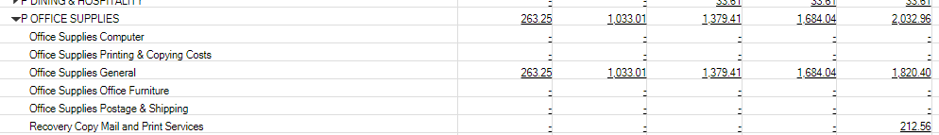
In the above example, $263.25 was spent in “Office Supplies General” in the fiscal period JUL-23. In the fiscal period AUG-23, $769.76 was spent in “Office Supplies General”. The total amount spent in 2 months was $1,033.01 (which appears in the report).
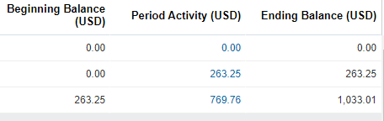
You are still able to “Drill into Account Detail” by clicking on the number in blue-
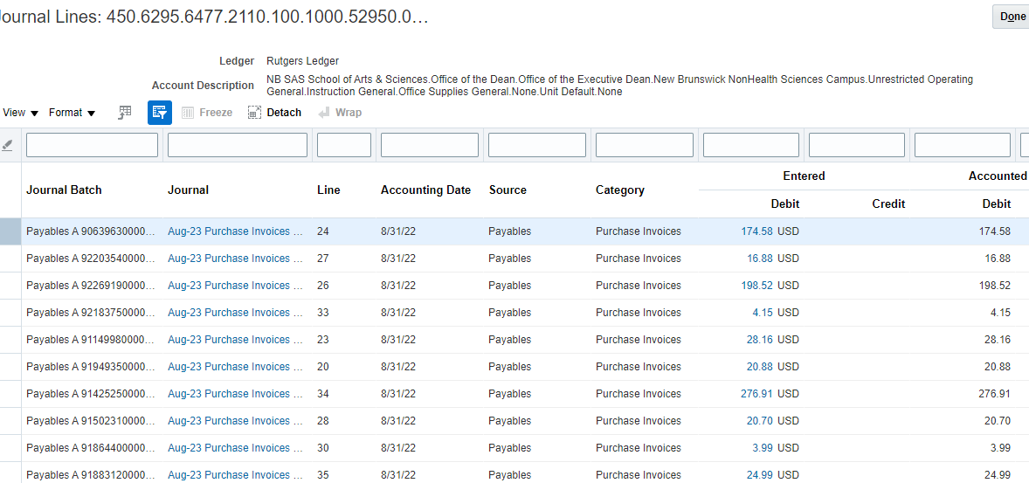
Quick Notes-
If you do not get a pop up to list your parameters, you need to set up “Point of Preview”
Setting up Parameters (POV) Preview for FRS Reports
When running General Ledger reports, it is easier to set up a Point of View to enter the parameters before the report runs. (If you do not set this up, whenever you run a General Ledger Report, the system will keep resetting the report as you enter the parameters)
Also, if you do not have point of view set up, and you run an “YTD” year to date report, the system will be looking for a starting point. (Example: the start of the fiscal year would be JUL-18) The system will ask that first, and then will error out because none of the other parameters have been entered.
To set up Point of View:
