Project Revenue Tab
The project revenue tab is on https://my.rutgers.edu 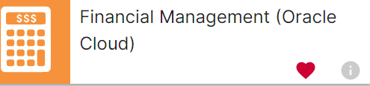
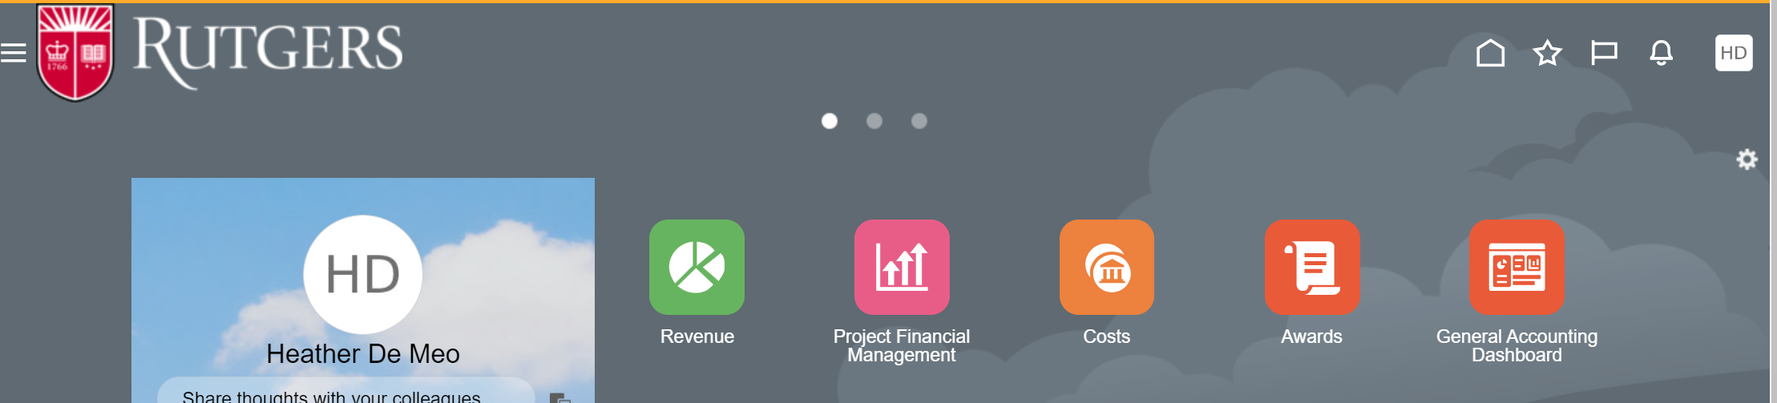
Click on the revenue tab-
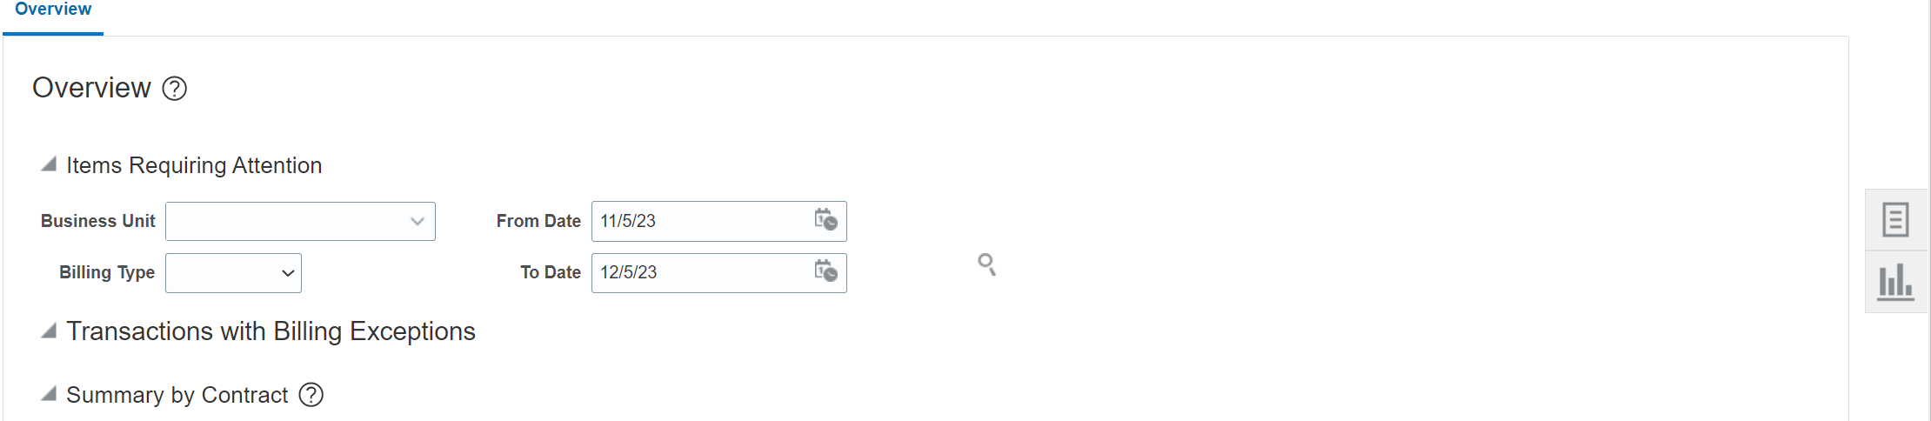
Click on the task icon.
Select “Manage Events”
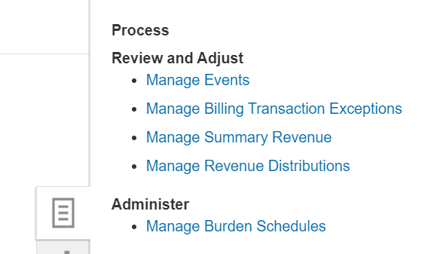

This will bring up the main screen.
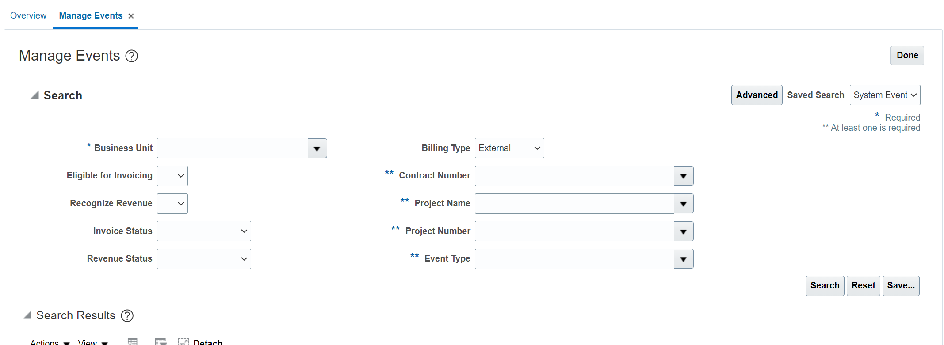
If you want to see the revenue for your project from creation to date, or Cornerstone conversion to date, select “Rutgers BU” from the “Business Unit” Drop down menu and enter your project number in “Project Number.” Click on search.
This will bring up your revenue from either project creation to date or Cornerstone Conversion to date.
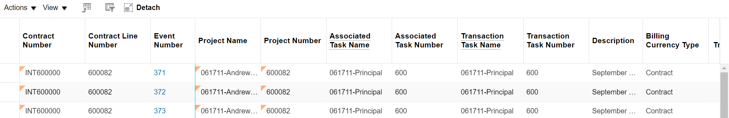
To export to excel- click on the export icon 
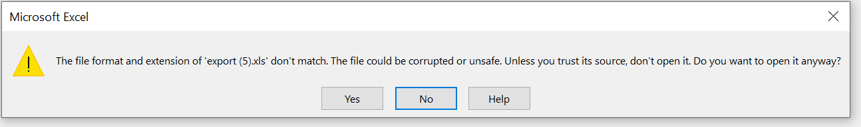
You will get warning message, just click yes to open the screen in excel and you can view your revenue.
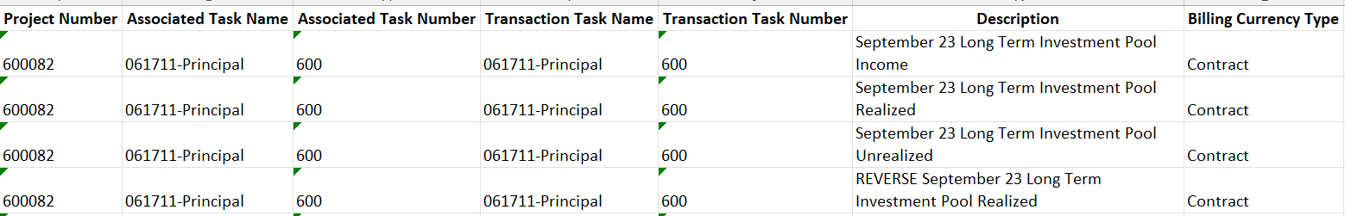
The advantage of this screen over the 505 for revenue is that you will see more description (if it was entered by whomever did the entry)
If you want to limit the timeframe of revenue entries to review, click on advanced from the main screen.
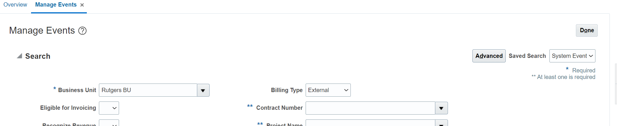
This will open more search criteria.
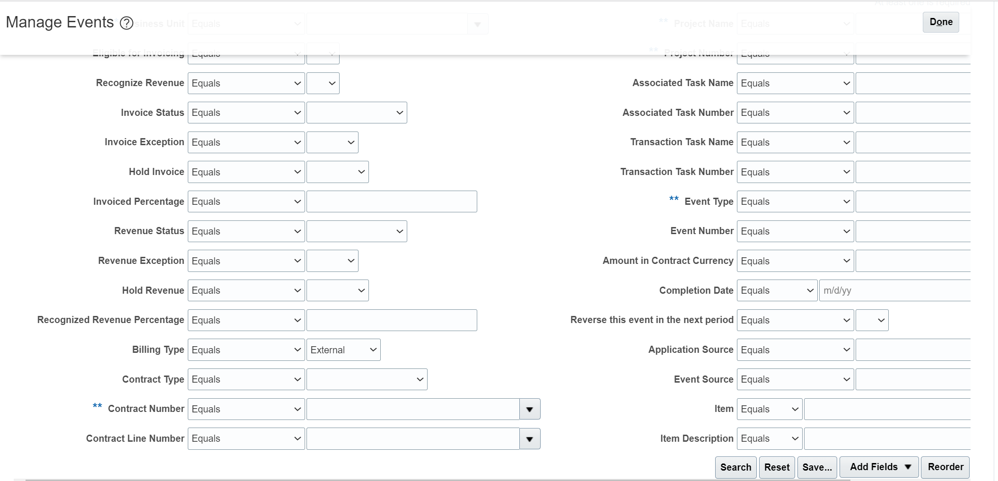
Completion Date: from the drop-down menu, select “Between” and it will open the dates for you to select your date range.
Fill in the rest of your search criteria to retrieve your data.

