Inquire on Details Screen in Cornerstone
The Cornerstone system allows direct access to transactions in the system. Cornerstone is a system that reports in totals, totals by month, totals by fiscal year, totals by account codes.
This can be cumbersome when you need to research individual items to hit the ledger.
You can access the “Inquire on Details Screen” through https://my.rutgers.edu 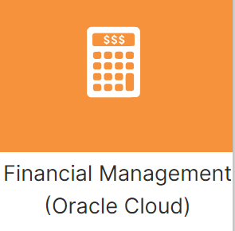
Click on the “General Accounting” and “General Accounting Dashboard” 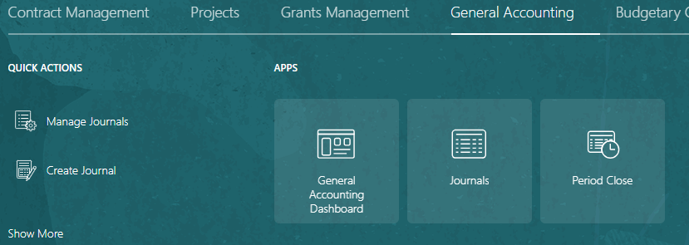
From the task box , click on “Inquire on Detail Balances” under “Inquiry and Reporting”
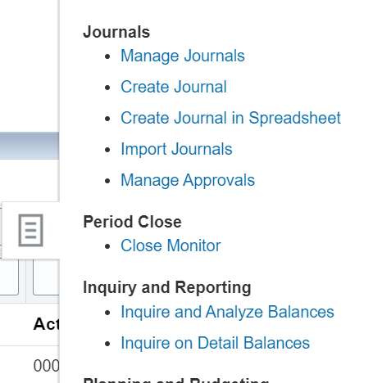
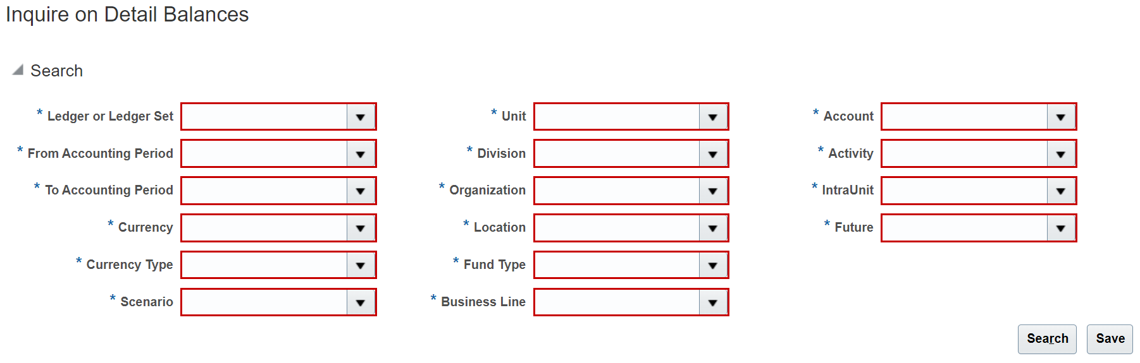
All the fields are mandatory to fill out. **Please note that you can not type the entries in, you must search and select your items.
- Ledger: Rutgers Ledger
- From Accounting Date: is the period (Example: Feb-24)
- To Accounting Date: is the period (Example: Mar-24)
- Currency: USD
- Currency Type: Entered
- Scenario: Actual (to see entries)
- Unit: Unit Code
- Division: Division Code
- Organization: Organization code
- Location: Location code
- Fund Type: Fund Type Code
- Business Line: Business Line Code that you are searching for, or “all” if you are searching for all the business lines in your unit.
- Account: Account code of the item you are searching, or the parent level, or “all” if you are searching for all account codes.
- Activity: All Activity Values
- IntraUnit: All Intraunit Values
- Future: All Future Values
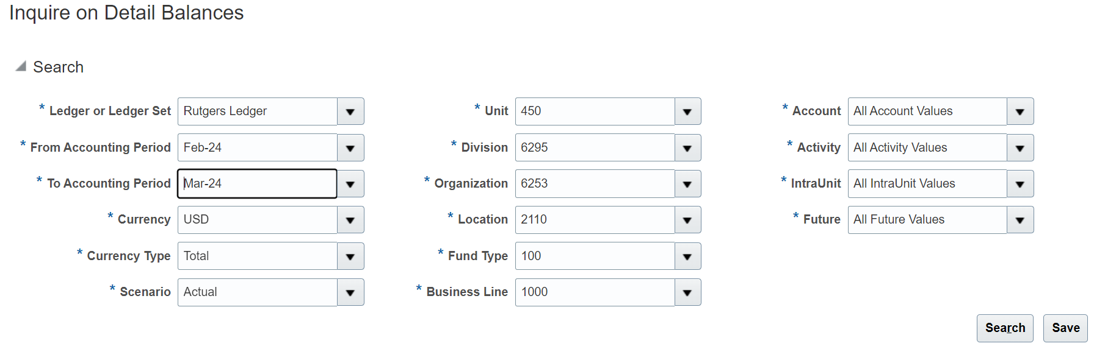
Based on your search criteria, you can see accounting period and the account codes for the strings you select.
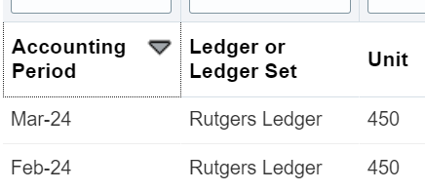
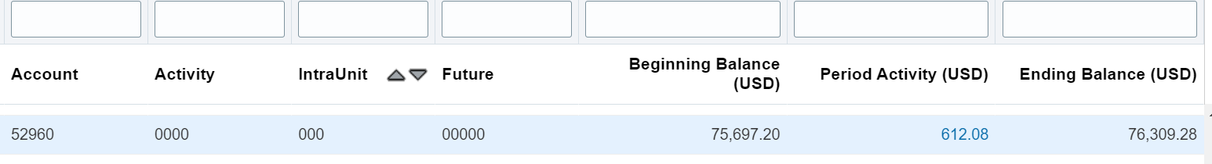
To get details on the items that make up the period activity for the month, click on the dollar amount. In the above example click on 612.08.
This will bring you into the details that make up that dollar amount (in the example, what makes up the 612.08)
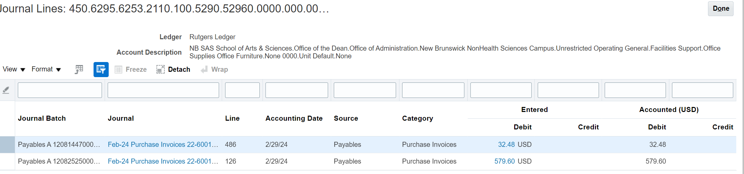
To see more details, click on one of the dollar amounts. This will bring you into the details of the entry.
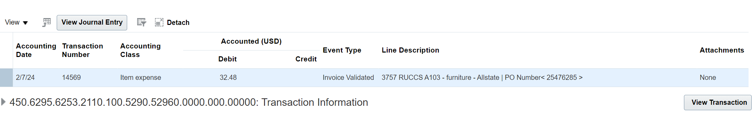
To go deeper into the item in questions, click on “view transaction.”
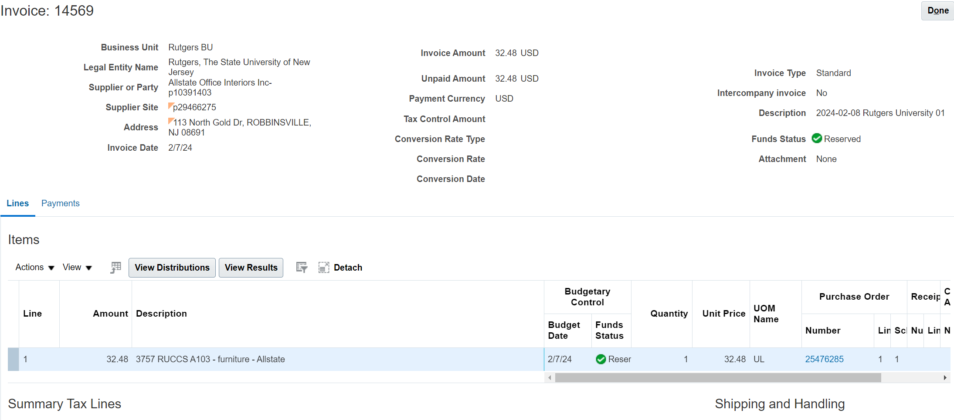
***Please note***
If you want to save your search, click on save from the main page.
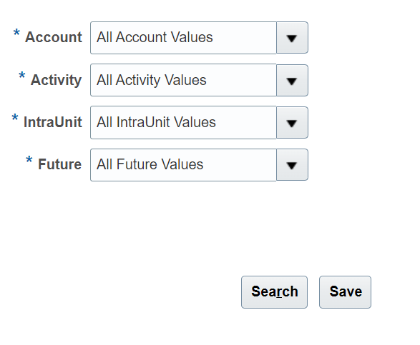
You can name your search and save it as your default. This way when you go into the screen, your details are already saved.
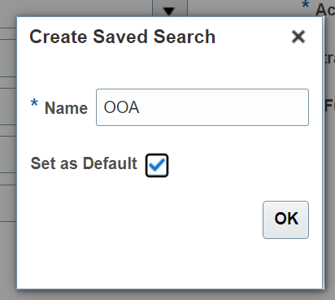
When you log on, you will go directly to your search selection.
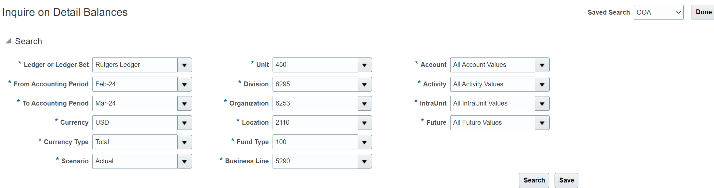
You will need to change the dates to update the finance periods.

