GL Account Analysis Report 089
The General Ledger is the operating account for your organization. The Account Analysis Report will show you the activity for the period you select.
https://my.rutgers.edu 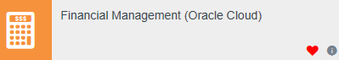
This report is a scheduled process, which means you have to set up the parameters.
Click on the following:
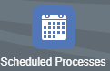
This will open your screen:
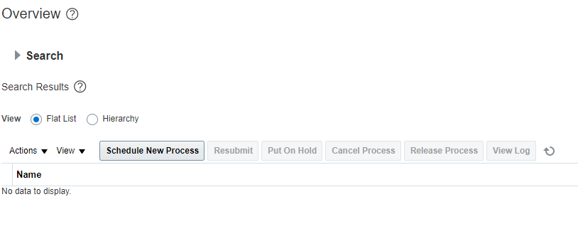
Click “Schedule New Process” this will open a selection window:
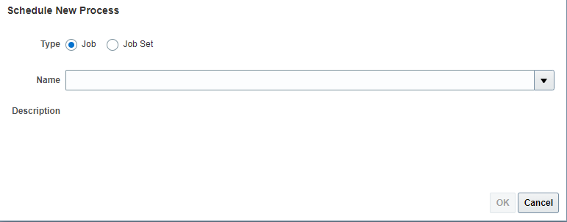
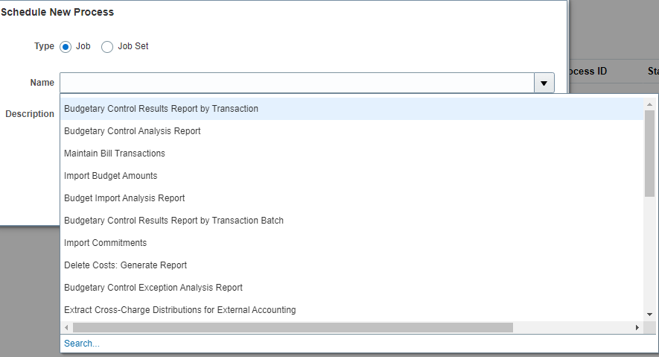
Click on Search
Search for Account Analysis:
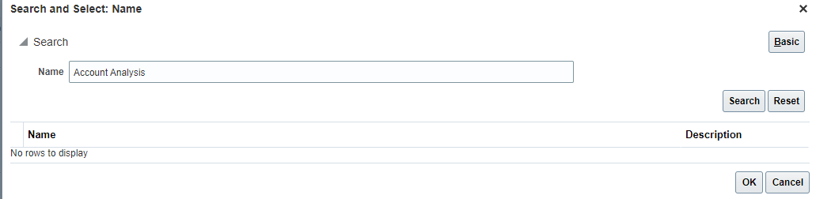
Select your report and click “OK”:
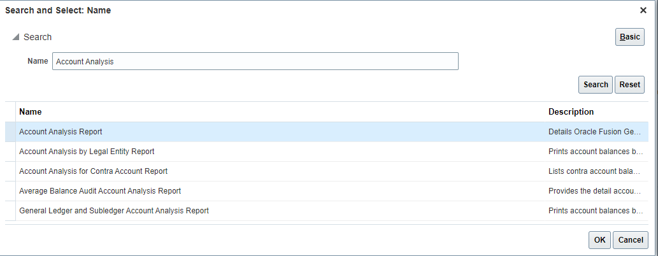
Click OK again:
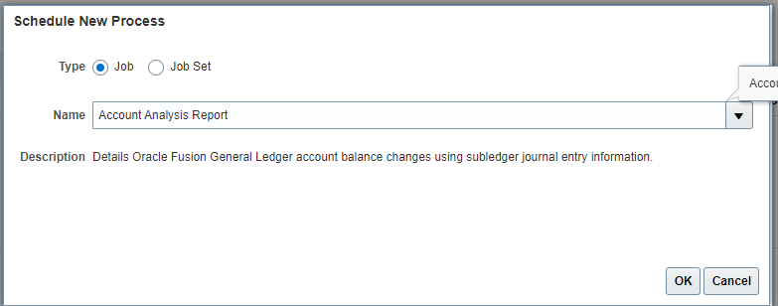
You will select your search criteria:

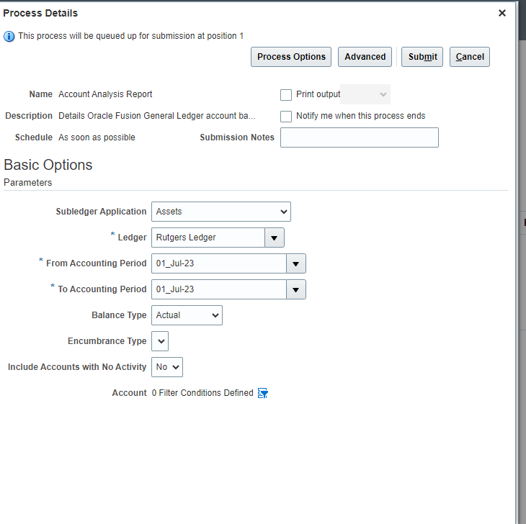
Select your account filters.
Select your period dates.
Keep as Rutgers Ledger

Subledger must be blank.
To select your filters, click
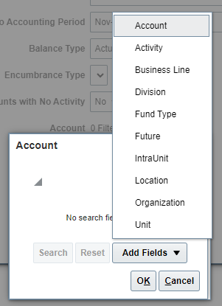
You can enter as many filters as you would like. Example, if you have multiple organization codes, you can list more than one.
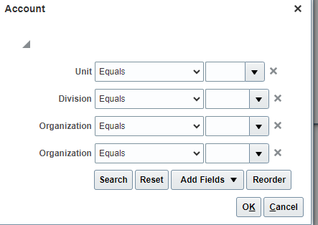
Be sure to enter in your data before clicking “OK”
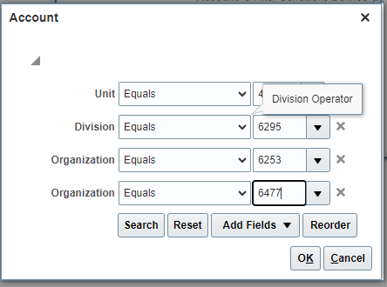
Once you have data entered, click on “Advanced.”
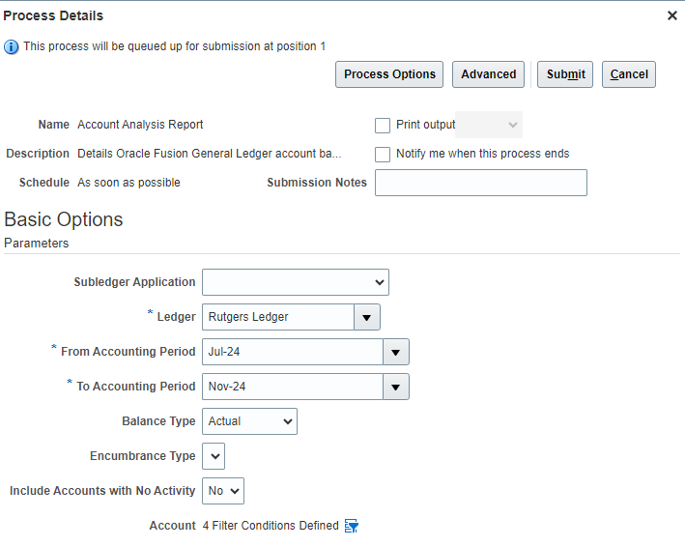
When in advance options, click on “+” to add the report.

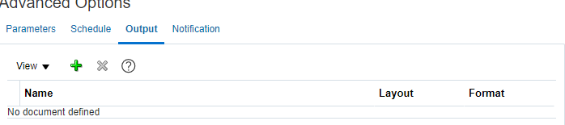
The default will RU GL 089 Account Analysis Report.
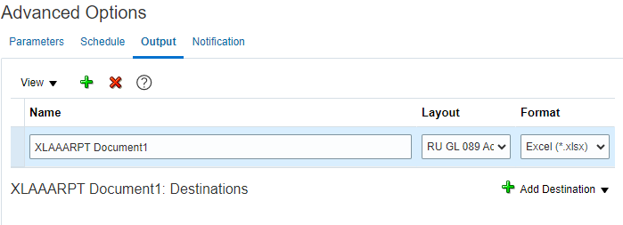
You can submit your report-
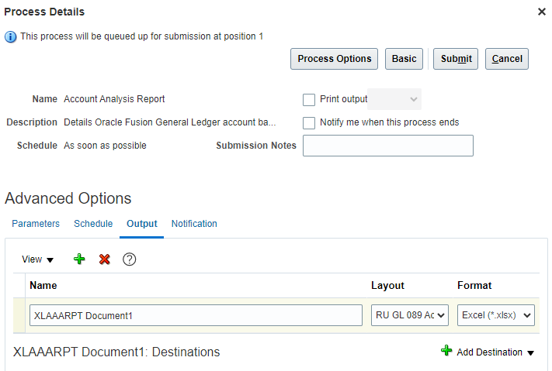
It will give you a confirmation number and go back to the main screen. It will look like nothing is processing. You will need to click on the refresh icon on the main screen to see your report
Click on you report:
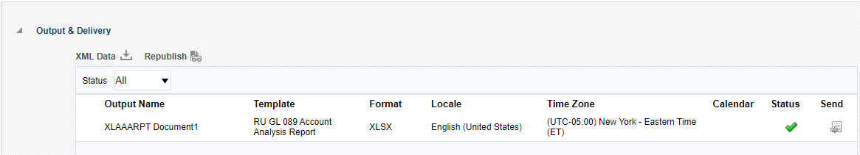
Click on XLAAARPT Document1 to get your report:
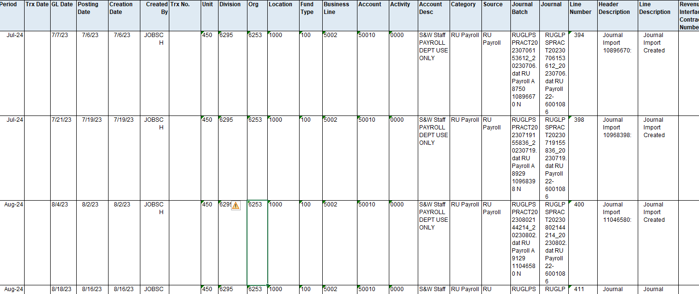
Excel will allow you to format your report as you would like to see your activity.
You can also add a pivot table.
The “Filters” can be what you need to see for the month (such as fund type and business line).
The columns can be the “Period” so you can see the total data by month.
The rows can be “Account Description” so you can see the subtotals for each group.
Values can be “Balance” so you can see the monthly charges.
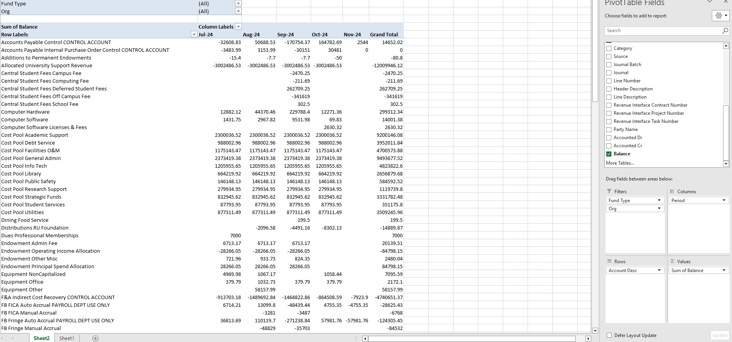
You can search for any data you want, and if the information seems wrong. You can click on the original sheet to see the activity data.

