Finding Project Information:
If you need to find out information about a project, you can do so with Cornerstone.
Log into https://my.rutgers.edu.
Click on 
Click on Project Financial Management 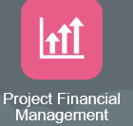
Click on the Task Icon and click on “My Projects”, then click on the “Search” arrow 
This will open the criteria page:
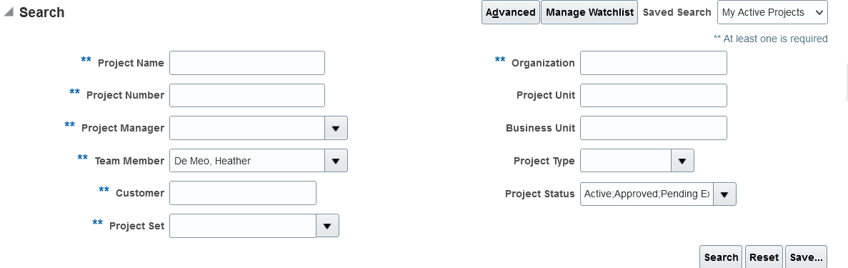
Click the search button
Enter your project number
Remove your name
This will bring you to your project-

Click on the project name or number, this will bring you to the project details-
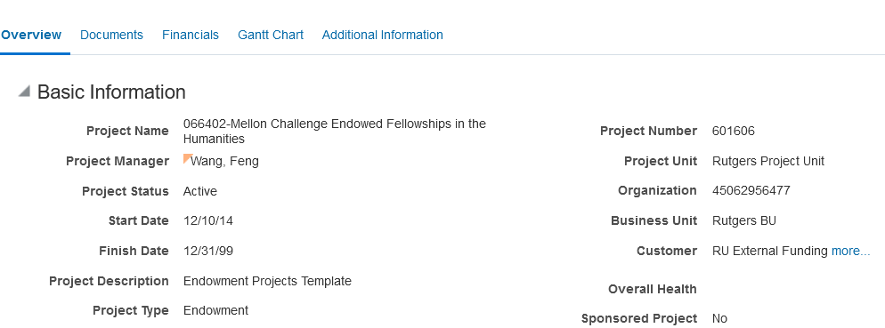
Click on Documents
This will bring you to any paperwork that is on file:
When you click on the “File Name or URL” you will be able to view the account opening documents.
