Cost Transfers-updated
If you are moving funds where there is a project involved, you need to process it via a cost transfer.
The spreadsheet used to facilitate the transfer is the “Create Non-Labor Costs for Third Party Applications”
Go to https://my.rutgers.edu, and access 
Click on “Costs” and click the task bar and click “Capture Costs” under “Capture”.
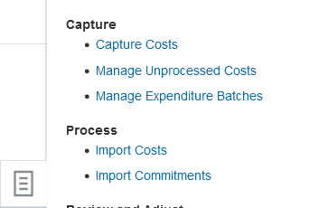
Select “Create Nonlabor Costs for Third-Party Applications”
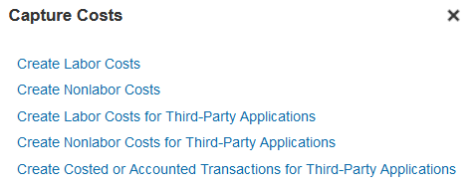
This will open up your spreadsheet
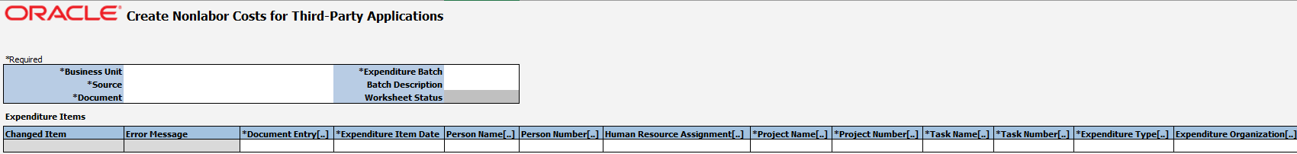
Fill out the first part as you normally would (the Header Section)
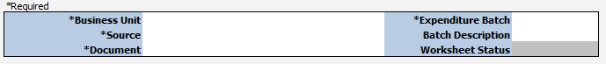
- Business Unit: Rutgers University
- Source: RU Project Transactions
- Documents:
  - 01: Project Cost Transfer (Project to Project)
  - 02: Project and GL Cost Transfer (Project to GL or GL to Project)
- Expenditure Batch:
  - Enter your unique JE name
Complete the Entry as normal:
- Document Entry: Copy what was previously entered into the document field (either 01- Project to Project Cost transfer, or 02 Project and GL cost Transfer)
- Expenditure Item Date: date of transfer
- Project Number and Project Name: enter the project number and name of the project (you can also click under the project number or name to search for the project number (the name will fill in from the system)
  - 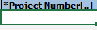
Double click here to search
  - 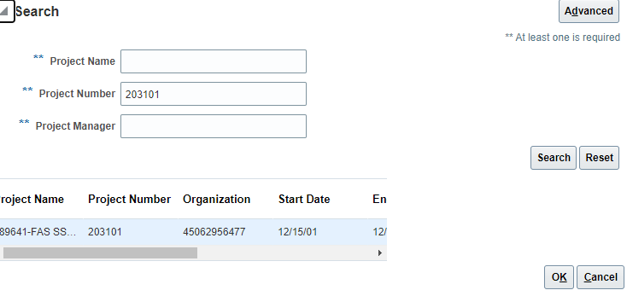
  - It will fill in the project name for you
  - 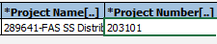
- Task Number and Task Name: enter the task number and task name. (click under task number to get the task name (similar to the project name listed above)
- Expenditure type: The account code for your transfer.
- Expenditure Organization: The UDO as one number for the project listed
Fill in the quantity of the transfer. If you are crediting the project, enter it as a negative and select “Yes” from the drop down menu in “Unmatched Negative Number”. If you are crediting the GL, enter it as a positive and leave “Unmatched Negative Number blank”
Expenditure comments: enter the details of your transaction
Transaction Currency: enter USD
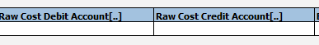
- Raw Cost Debit Field: Leave blank
- Raw Cost Credit Field:
  - The GL string is only needed for the GL side of the cost adjustment (project to GL, GL to project)
  - Leave blank if you are processing project to project. The system will used the project setup string to record the accounting transactions for the project side.
You will be able to submit your entry by clicking on export
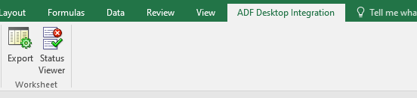
PLEASE REMEMBER THAT YOU NEED TO SUBMIT YOUR ENTRY THROUGH THE MANAGE EXPENDIURE BATCH SECTIONS. THAT HAS NOT CHANGED!

