Updated BETA 145 GL and Sub Ledger Transaction Report-
The BETA 145 GL and Sub Ledger transaction report.
Oracle limits 9 minutes for any report on screen. When running reports for a wide range of data (ex. Full fiscal year) can take longer than 9 minutes, so in order to run the report successfully it must be scheduled.
https://go.rutgers.edu/2yyt6s63
When you are in the scheduler, click on  and select “Schedule” from the menu.
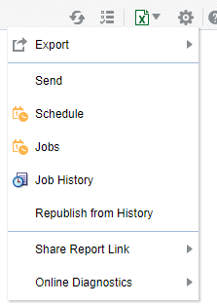
This will open up the Report Job screen where you can select your criteria-
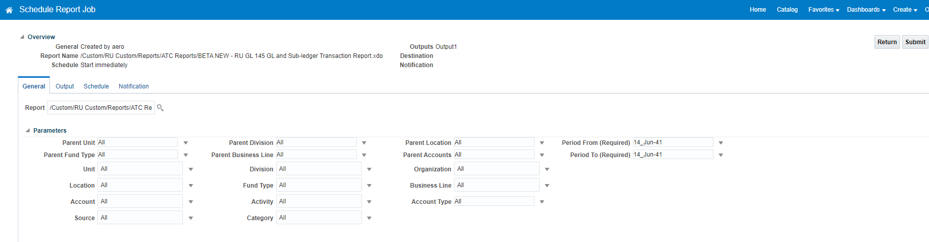
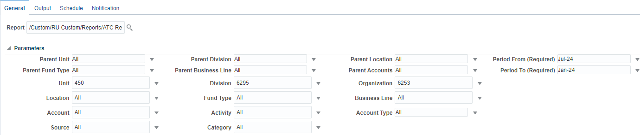
Once you have selected your search criteria, click on output (next tab over) 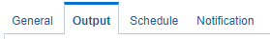
You can add your destination- 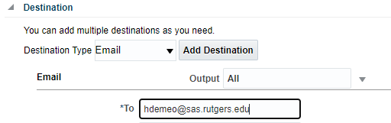
Click Schedule 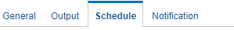to run now 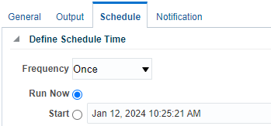or to schedule the report for when you need (or recurring) .
If you want to be notified when the report is done (with a link to your report) click Notification 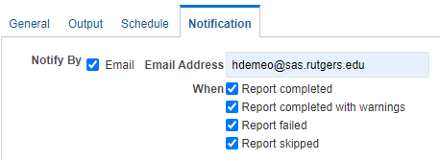
When you are done, click submit- 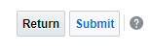
You will need to name your report in “Report Job Name.”
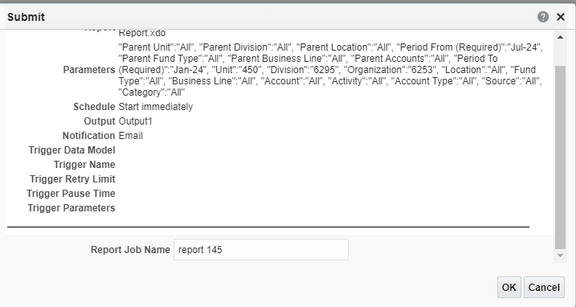
Click OK and Oracle will let you know that your report was successfully submitted - 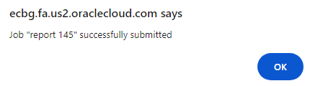
You can also click on https://ecbg.fa.us2.oraclecloud.com/analytics/saw.dll?bipublisherEntry&Action=history to retrieve your report when it is done running.
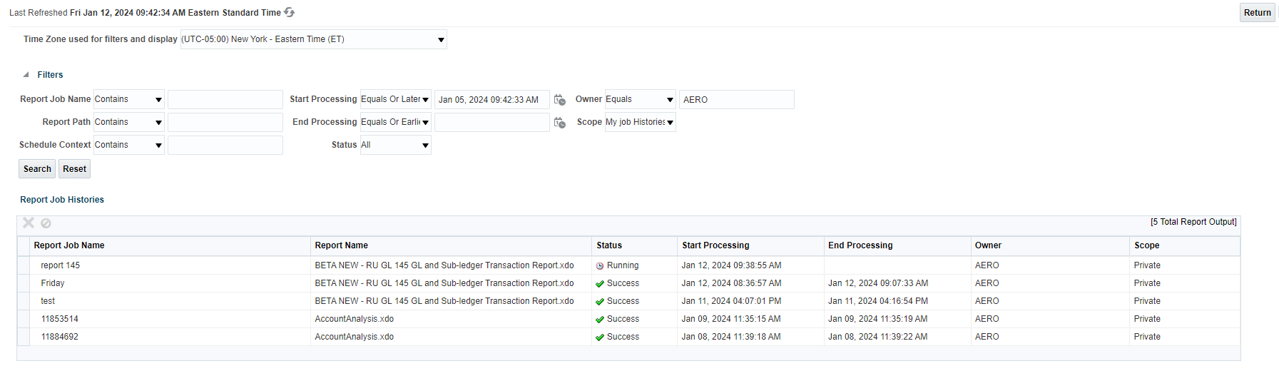
Click on “Output” to see your report. It will download to excel.
